TP-İZGİN TERMİNAL

DANGEROUS GOODS GUIDE
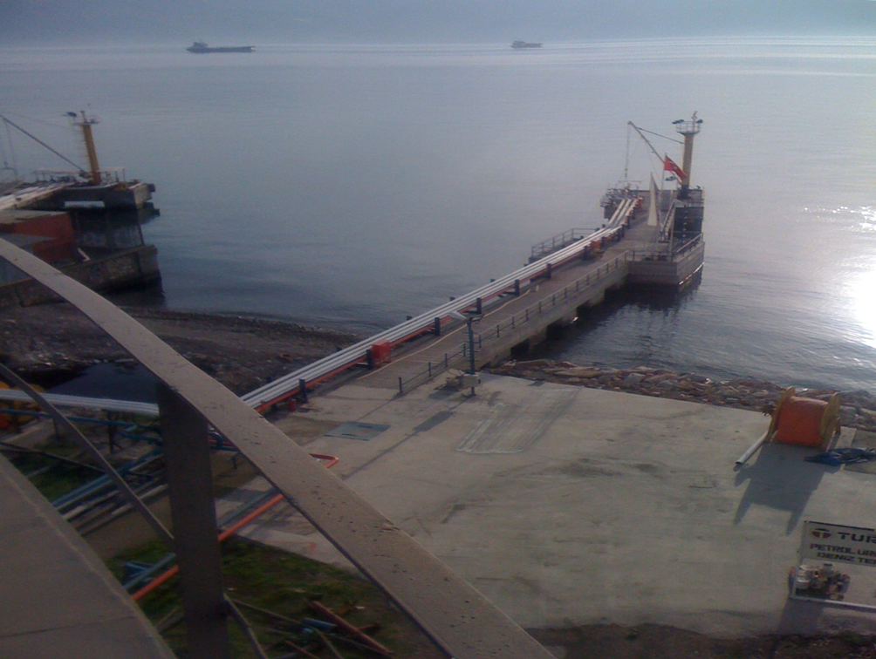

ISSUE DATE: 01 JANUARY 2016
(See the revisions in Revision Page)

REVISION PAGE
Row No | Revision No | Revision content | Revision Date | Revised by
 |  |  |  | Name Surname | Signature
1 | 01 | Accident Prevention Policy and Hazardous Liquid Bulk Loading Procedure | 13/11/2017 | Turhan GÜREFEOĞLU
2 | 02 | New Company Name | 01/03/2019 | Murat ŞERBETÇİ

CONTENTS
1. REVISION PAGE 2
2. CONTENTS 3
1. INTRODUCTION 7
1.1 Genel information of facility 7
1.2 Loading/discharge, handling and storage procedures of dangerous goods handled and temporarily stored in shore facility 10
2. RESPONSIBILITIES 16
2.1 Responsibilities of those responsible for the goods: 11
2.2 Responsibilities of shore facility operator: 12
2.3 Responsibilities of ship master: 14
2.4 Responsibilities of Dangerous Goods Safety Advisor: 15
2.5 Responsibilities of third party, cargo/ship agency engaged in shore facility 21
3. RULES TO BE FOLLOWED/APPLIED AND MEASURES TO BE TAKEN BY SHORE FACILITY : 18
3.1 Rules to be followed by Shore facility Operators: 18
3.2 Measures to be taken by Shore facility Operators: 19
4. CLASSES, TRANSPORTATION, LOADING/DISCHARGE, HANDLING, SEGREGATION, STOWING AND STORAGE OF DANGEROUS GOODS 23
4.1 Classes of Dangerous Goods: 23
4.2 Packs and packagings of dangerous goods: 24
4.3 Placards, plates, brands and labels related to the Dangerous goods handled in our shore facility are as follows. (Placards, plates, brands and labels of Dangerous goods that not handled in our shore facility and detailed information are as in Chapter 5 of IMDG CODE .) 25
4.4 Marks and packaging groups of dangerous goods 36
4.5 Segregation tables of dangerous goods aboard ship&port according to classes:……………………………………………………………………………………………………………………27
4.6 Segregation distance of dangerous goods in shed storages and segregation terms . 32
4.7 Dangerous Goods documents: 32
5. MANUAL FOR DANGEROUS CARGOES HANDLED IN SHORE FACILITY 33
6. OPERATIONAL ISSUES 34
6.1 Procedures for safely berthing, mooring, loading/discharging, harbouring or anchoring of ships transporting dangerous goods at night and day 41
6.2 Procedures for additional measures taken for loading, discharging and transshipment according to seasonal conditions. 34
6.3 Procedures for keeping away flammable, combustible and explosive materials from spark-producing operations and not operating vehicles, equipment and tools capable of sparking in fields of dangerous goods handling, stowing and storage . 35
6.4 Procedures for fumigation, gas measuring and degassing . 35
7. DOCUMENTATION, CONTROL AND RECORD 37
i. Container /Vehicle Packing Certificate 37
ii. Documents required aboard 37
iii. Other required documents and information 37
iv. Multi Model Dangerous Cargo Form 37
7.3 Procedures for control of properly defining of dangerous goods in the facility, using proper shipping names,certificating, packaging/packed, labeling and declaring of dangerous goods, loading to approved package, container or good cargo transport unit in accordance with rules and transporting in a safe condition and reporting the results of control ……………………………………………………………………………………………………………………41
7.4 Procedures for obtaining and keeping dangerous goods safety information form (SDS). 41
7.5 Procedures for keeping records and statistics of dangerous goods. 42
8. EMERGENCIES, PREPAREDNESS FOR EMERGENCIES AND RESPONSE Hata! Yer işareti tanımlanmamış.
8.1 Response procedures for dangerous goods that endangers/able to endanger life, property and/or environment and dangerous incidents involving dangerous goods ……………………………………………………………………………………………………………………43 8.2 Information for possiblity, capacity and capability of shore facility to response emergencies. 47
8.3 Regulations of first Response for accidents involving dangerous goods . 48
8.4 Notifications to be made inside and outside of facility in emergencies. 51
8.5 Procedures for reporting accidents 51
8.6 Coordination, support and cooperation method with public authorities. 51
8.7 Emergency evacuation plan for ship and sea vehicless from shore facility in emergencies . 51
8.8 Procedures for handling of damaged dangerous goods and wastes contaminated to dangerous goods and disposal of them. 52
8.9 Emergency drills and their records 56
8.10 Information for fire protection systems. 54
8.11 Procedures for approval, inspection, test, maintenance of fire protection system and keeping it ready for use. 55
8.12 Measures to be taken when the fire protection systems do not work 55
8.13 Other risk control equipment. 55
9. OCCUPATIONAL HEALTH AND SAFETY 56
9.1 Occupational health and safety measures: 56
9.2 Information for personal protective clothing and procedures for using them: 56
10. OTHER ISSUES 57
10.1 Validity of Dangerous Goods compliance Certificate. 57
10.2 Duties defined for Dangerous goods safety advisor. 57
10.3 Issues for carrier of dangerous goods to the shore facility /from the shore facility by land (documents to be kept by road vehicles during entrance/exit of port or shore facility field, equipment and tools kept by these vehicles; port field speed limits, etc): 59
10.4 Issues regarding to the carriers of dangerous goods to coming the shore facility/leaving from shore facility by sea (exhibition of signals by ships and sea vehicles to the port or shore facility by day/at night, cold and hot working procedures aboard ship) 60
10.5 Additional issues added by shore facility. 61
11. ANNEXES 62

ANNEX-1 General Layout of Shore facility
ANNEX-2 Photo of General Appearance of Shore facility
ANNEX-3 Emergency Contacts and Contact Information
ANNEX-4 General Layout Plan of Fields that Dangerous Goods Handled
ANNEX-5 Fire Plan of Field that Dangerous Goods Handled
ANNEX-6 General Fire Plan of Facility
ANNEX-7 Emergency Action Plan
ANNEX-8 Emergency Meeting Point Plan
ANNEX-9 Emergency Management Plan
ANNEX-10 Dangerous Goods Manual
ANNEX-11 Leakage Areas, Equipment, Entrance/Exit Drawings for CTU and Packages
ANNEX-12 Inventory of Port Service Ships
ANNEX-13 Port Authority Administrative Boundaries, Anchoring Locations and Harbor Pilot Marine coordinates of Landing/boarding points
ANNEX-14 Emergency Response Equipment against Marine Pollution in Port facility
ANNEX-15 Personal Protective Equipment (PPE) Use Map
ANNEX-16 Notification Form for Dangerous Goods Incident
ANNEX-17 Notification Form for Control Results of Dangerous Goods Cargo Transport Units (CTUS)
ANNEX-18 Multimodal Dangerous Goods Form
ANNEX-19 Accident Prevention Policy
ANNEX-20 Safe Handling Procedure of Liquid Bulk Loads

INTRODUCTION
When the dangerous goods are handled or stored in entrance of port and port areas, general safety and security must be provided, the goods must be surrounded, all safety measures must be taken for all people in or near port area and the environment must be protected, all these must be controlled.

General information of facility
FACILITY INFORMATION FORM
1 | Name/title of facility operator |  |  |  | TP PETROL DAĞITIM A.Ş / İZGİN DEPOCULUK LTD ŞTİ
2 | Contact Information of facility operator (address, phone, fax, e-mail and web page) |  |  |  | ATALAR MAHALLESİ,HAYAT SK. NO:5  KÖRFEZ/KOCAELİ  Phone : 0 262 5281237  Fax : 0 262 5285852
3 | Name of facility |  |  |  | TP-IZGIN TERMİNALİ
4 | Province of the facility |  |  |  | KOCAELİ
5 | Contact Information of facility (address, phone, fax, e-mail and web page) |  |  |  | ATALAR MAHALLESİ, HAYAT SOK. NO:5  KÖRFEZ/KOCAELİ  Phone : 0 262 5281237  Fax : 0 262 5285852
6 | Geographical area of facility |  |  |  | MARMARA
7 | Port Authority of facility and contact details |  |  |  | KOCAELİ HARBOUR MASTER
8 | Mayor ship of facility and contact details |  |  |  | KÖRFEZ MAYORSHIP
9 | Free Zone or Organized Industrial Zone of facility |  |  |  | -
10 | Validity date of shore facility Operating Permit/Provisional Operating Permit |  |  |  | 13.12.2022
11 | Facility operating status (X) |  |  |  | Own load and add.third party (…) |  | Own load  (X) |  |  | Third part  (….)
12 | Name and surname of facility responsible person, contact information (phone, fax, e-mail) |  |  |  | MURAT ŞERBETÇİ  Phone : 02625281237  Fax : 02625285852  mserbetci@tppd.com.tr
13 | Name and surname of responsible person for dangerous goods operation of facility, contact information information(phone, fax, e-mail) |  |  |  | MURAT ŞERBETÇİ  Phone : 02625281237  Fax : 02625285852  mserbetci@tppd.com.tr
14 | Name and surname of Dangerous Goods Safety Advisor of Facility, contact information information(phone, fax, e-mail) |  |  |  | NOT DISCERNED YET
15 | Marine coordinates of facility |  |  |  | 40º 46' 15" N – 029º 43' 10" E
16 | Type of dangerous goods handled in facility (goods under MARPOL Annex-1, IMDG Code, IBC Code, IGC Code, IMSBC Code, Grain Code, TDC Code and asphalt/bitumen and scrap goods) |  |  |  | UN1202 DIESEL FUEL APPROPRIATE TO THE STANDARD OF EN 590:2004 OR GAS OIL OR HEATING OIL;  UN1170 ETHANOL(ETHYL ALCOHOL OR ETHANOL SOLUTION (ethyl alcohol solution);UN1171 ETHYLENE GLYCOL MONOETHYL ETHER;  UN1114 BENZENE;UN1824 SODIUM HYDROXIDE SOLUTION;  UN 2748 2-ETHYL HEXENYL CHLOROFORMATE
17 | Types of Ship berthing to facility |  |  |  | PETROLEUM/PRODUCT TANKER, CHEMICAL TANKER
18 | Facility’s distance to main road (kilometer) |  |  |  | 500 MT
19 | Facility’s distance to railway (km) or railway connection (Yes/No) |  |  |  | BORDER
20 | Facility’s distance to closest airport (km) and its name |  |  |  | SABİHA GÖKÇEN / 45 KM
21 | Goods handling capacity of facility  (Ton/Year; TEU/Year; Vehicle/Year) |  |  |  | 250.000 TONE/YEAR
22 | Scrap handling made/not made in facility |  |  |  | NO
23 | Is there border crossing (Yes/No) |  |  |  | YES
24 | Is there a bonded areas?(Yes/No) |  |  |  | YES
25 | Goods Handling equipment and capacity |  |  |  | 6 X 6" PIPELINE  FLEXIBLE HOSE, FIXED CRANE, FORKLIFT
26 | Storage tank capacity (m³) |  |  |  | NO STORAGE IN SHORE FACILITY
27 | Open storage area (m²) |  |  |  | NO STORAGE IN SHORE FACILITY
28 | Semi-closed storage area (m²) |  |  |  | NO STORAGE IN SHORE FACILITY
29 | Closed storage area (m²) |  |  |  | NO STORAGE IN SHORE FACILITY
30 | Determined fumigation and/or decontamination from fumigation area (m²) |  |  |  | NONE
31 | Name/title of pilotage and towage service provider, contact information |  |  |  | DEKAŞ / MED MARINE
32 | Is Safety Plan created?(Yes/No) |  |  |  | YES
33 | Capacity of Waste Acceptance Facility  (This part will be issued separately according to the waste accepted by facility) |  |  |  | Atık Türü |  |  | Kapasite (m³)
33 |  |  |  |  | EXEMPT
34 | Characteristics of berth/jetty etc. Areas
Berth/Jetty No |  | Height (meter) | Width (meter) | Maximum water depth  (meter) |  | Min, mum water depth  (meter) |  |  | Tonnage and height of The largest ship berthed  (DWT or GRT - meter)
1 |  | 46,5 | 6 | 8,5 |  | 6.5 |  |  | 15.000 DIS.TONAGE
Name of pipe line (if available in facility) |  |  |  | Number  (pieces) |  | Height  (meter) |  |  | diameter  (inch)
PRODUCT HANDLING LINE |  |  |  | 6 |  | 450 |  |  | 6"

Loading/discharge, handling and storage procedures of dangerous goods handled and temporarily stored in shore facilities

Dangerous goods handled and stored temporarily in our facility are as follows .

UN | NAME AND DEFINITION | CLASS | PACKAGING | TK
UN1202 | DIESEL EN 590:2004 GAS OIL OR HEATING OIL MOTOR ALCOHOL OR GASOLINE OR PETROLEUM IN COMPLIANCE WITH STANDARD | 3 | III | 30
UN1170 | ETHANOL(ETHYL ALCOHOL or ETHANOL SOLUTION (Ethanol Alcohol Solution) | 3 | II | 33
UN1171 | ETHYLENE GLYCOL MONOETHYL ETHER | 3 | III | 30
UN1114 | BENZENE | 3 | II | 33
UN1824 | SODIUM HYDROXIDE SOLUTION | 8 | III | 80
UN 2748 | 2-ETHYL HEXENYL CHLOROFORMATE | 6.1 | II | 68

Loading/Discharging Procedure for Dangerous Goods handled and Temporarily Stored

Load/discharge Procedure for Dangerous Goods transported by Sea

Ship Discharging team, ship arrival date, type and quantity of the arriving product, tanks to be discharged and information involving the discharging order will be announced by operation before the ship arrives.
The ships to be discharged must have “APPROVAL” from TURKUAZ Terminal Facility Director. Berthing will be reported by contacting with DEKAŞ Pilotage and Port authority.
Operation Supervisor is obliged to implement and enforce to implement rules fully, he is primarily responsible for execution of the operation in safe condition.

- When the ship to be discharged, communicates with radio by support of pilotage and tugboats when arriving to jetty, and requests to berth the ship. Operation supervisor coordinates berthing of the ship. The ship which is not foreseen or is deemed inconvenient by Operation supervisor will not let berthing to jetty.
- If the product on board is transit, nobody can come on board before customs agent responsible persons or cargo manifest sent by customs.
- After the ship berths to jetty appropriately and moors in accordance with “Turkuaz Facilities Ship Mooring Types”, if the arriving product is not NATIONAL (Customs-Free), Customs agency must issue Warehouse Declaration and make it approved by customs authorities, take permission to come on board and wait to take out the Customs seals on ship tanks by authorities. After the required procedures in Customs Directorate and Customs House Department are completed, facility will starts discharging procedure.
- Operation supervisor comes on board with personnel of Inspection Company, takes the notice of readiness, checks the seals, and supervises measurement of tank and bunker fuel. Meanwhile, sample/samples are taken by laboratory personnel according to the defined rules and tested, they are recorded, the operation supervisor will be informed about the result/results.
- During this process, operation supervisor makes “Product Meeting Before Discharge” with master, fills all the articles mentioned in the form with assessment together with master, after required signatures and seals are made, one copy is left on board, other copy is taken by Operation Supervisor and brought to Production Directorate to be archived.
- Before discharge, technical security will be informed, maintenance and repair work in the tank area shall be secured .
- After the meeting, “Ship/Shore Safety Check List” is filled by controlling one by one walking aboard ship and on jetty. When facing an improper situation about the list, the discharge is not started unless the situation is recovered (or if detecting an unsafe situation during discharging, discharge is stopped and not started till it’s corrected).
- After measurement report of inspection company, laboratory approval of tested samples are taken, measurement of shore tanks are made, information involving shore tank of the product is ready, valves in jetty manifolds and valves in tank area are controlled and filled in “PRE-DISCHARGE CHECKLIST” by operation supervisor, discharge can be started by instruction of operation supervisor.
- During discharging, ship must be constantly under supervision of at least one Turkuaz official, operation supervisor must control the ship during every product change and at least every hour whether any change “Ship/Shore Safety Check List” occurs or not. Operation supervisor writes down the line pressure values at the beginning of ship pump room/manifold and filling line in jetty to the relevant form every hour.
- Operation supervisor provides the personnel to rest periodically in order to keep personnel in Shore and Tank area active.
- If there is shift change in discharging, shift change form is filled and signed by operation supervisor. All information is transferred to the assigned supervisor orally.
- Operation supervisor fills all documents and gives one copy to the ship in order to make the closing. All documents together with other documents from the ship will be filed in Production Directorate.
- Operation supervisor acts according to emergency action plan in case of emergencies.
- During product transitions, instructions for taking and throwing pig ball using in line cleaning must be followed. During product transition, radio must be repeated with ship, information must be verified in tank area and confirmed with personnel in jetty.
- As crane is used while taking or giving hose, operation supervisor must be at this point.
- Documents involving last waste is released and slops are pressed must be requested from ship and put in ship discharge file.
- All ship team including third parties must wear life jackets in accordance with min. EN 396 100N or higher standard for the conditions mentioned below.
  - Berthing or removing maneuvers of ship
  - Connecting/disconnecting the ship-shore hose
  - Taking samples from ship/making measures
  - Bad weather conditions( absolutely wind with 3 beaufort or more )
  - Shore ship stairs that has pulpit lower than 70 cm .

Load/discharge procedure for Dangerous Goods by Road;

There is no load/discharge of dangerous goods by road in the shore facility.

Handling Procedure for Dangerous Goods handled and temporarily stored:

The procedure for the dangerous goods handled in our Port Facility under IMDG Code is as follows.
A coordination meeting is conducted for dangerous goods under IMDG Code which is transported to the Port and;

- Handling time of dangerous goods in the facility,
- Obligation for wearing protective clothing and the features of these clothing,
- Response opportunities and risks that may occur during Emergency Response situation (Fire and Spilling) ,
- Issues such as special measures mentioned about the cargo, should be taken or not, shall be decided and emergency response procedures are taken into account according to the facility potential by using equipment and clothings stated during handling in order to respond immediately.

Storage Procedures:

There is no storage in shore facility.

RESPONSIBILITIES

All measures for safe and secure transport without any harm to environment, preventing accidents and reduce the damage all the way when the accident happens will be taken in our facility, the responsible authorities for these and their responsibilities are as follows.

Responsibilities of those responsible for goods:

Preparing all required document, information and papers related to dangerous goods or making them prepared, providing these documents keeping together with the goods during the carrying procedure.

Providing classification, identification, packaging, signing, labelling and placarding of the dangerous goods in accordance with the legislation.

Providing loading, stowing, securing, transporting and discharging the dangerous goods in approved package, container and cargo transport units in accordance with the rules.

Providing the training the related personnel about risks, security measures, safe operation, emergency measures, safety and similar issues of dangerous goods transported by sea and recording these trainings.

Providing taking required safety measures for dangerous goods that are against rules, insecure or having risk against people or environment.

Providing required information and support to the relevant people in case of emergency or accident.

Informing the administration about accidents of dangerous goods that happened in responsible area.

Providing the information and documents requested in the controls by public authorities and providing necessary cooperation.

Responsibilities of shore facility operator:

Providing the ships berthing and mooring in appropriate sheltered, safely condition.

Providing entrance-exit system between ship and shore appropriately and secured.

Providing training to the people in charge of loading, discharging and handling of dangerous goods.

Providing the dangerous goods to be transported, handled, segregated, stowed, waited temporarily and inspected by personnel who is qualified, trained and take the occupational safety measures, in safe condition in accordance with the rules.

Requesting all required document, information and papers related to dangerous goods from those responsible for goods and providing them accompanying with the goods.

Keeping the updated list of dangerous goods in operating field.

Providing the training to the operating personnel about risks, security measures, safe operation, emergency measures, safety and similar issues of dangerous goods handled and recording these trainings.

Controlling the documents in order to confirm that dangerous goods are entered to the facility, are identified, classified, certificated, packed, labeled, declared, loaded to the approved and appropriate packages, container and cargo transport unit in safe condition, and transported according to the procedure.

Taking required safety measures for dangerous goods that are against rules, insecure or having risk against people or environment and informing the port authority.

Providing making arrangement for emergencies and informing related people.

Informing the port authority about accidents of dangerous goods that happened in responsible area.

Providing the information and documents requested in the controls by public authorities and providing required cooperation.

Making the activities related to dangerous goods in berths, jetty, storages, warehouses which are designated for these activities.

Equipping the berths and jetty with appropriate qualified equipment and installation, which are designated for the ship and sea vehicles that loads and discharges bulk petroleum and petroleum product.

Providing the transportation of the dangerous goods which are not suitable or not allowed for temporarily waiting in operating field, to the out of shore facility as soon as possible without waiting.

Disallowing berthing to jetty or berth for the ship and sea vehicles transporting dangerous goods which do not have port authority’s permission.

Providing an appropriate storage field for containers of dangerous goods in accordance with segregation and stowing rules, taking required measures for fire, environment and other safety issues in this field. Taking required measures for other risks especially temperature in hot weather during loading, discharging, transshipping dangerous goods to ship or sea vehicle and people who carried out loading, discharging and transshipping together with people in charge of ship. Keeping the flammable goods away from spark-producing operations, not activating tools or vehicles which produce spark in dangerous goods handling field.

Preparing a emergency evacuation plan for evacuation of ship and sea vehicles from shore facilities in emergencies.

Responsibilities of Ship Master:

Providing equipment and devices of the ship to be in compliance with dangerous goods transport.

Requesting all required document, information and paper of dangerous goods from shore facility and those responsible for goods, providing to accompany the dangerous goods.

Providing full implementation and proceeding of safety measures for loading, stowing, segregation, transporting and discharging of dangerous goods aboard ship and making required inspection and controls .

Controlling the dangerous goods, entered to the ship, for identification, classification, certification, packaging, marking, labeling, declaring, loading to approved and appropriate packages, container and cargo transport units in a safe condition and transporting in accordance with the procedure.

Providing all ship personnel information and training for risks, safety measures, safe operating, emergency measures and similar issues related to dangerous goods transported, loaded, discharged.

Providing the people who take qualified and required trainings about loading, transporting, discharging and handling of dangerous goods, to operate as taking the occupational safety measures.

Not going out, anchoring of the field designated for him, not berthing to jetty or berth without the permission of port authority .

Applying all rules and measures during sailing, maneuvering, anchoring, berthing and departing for transportation of the dangerous goods in safe condition.

Providing safe entry and exit between ship and berth.

Informing the personnel about application, safety measures, emergency measures and response methods about dangerous goods.

Keeping the updated list of all dangerous goods aboard ship and informing the relevant authorities.

Taking required safety measures for dangerous goods that are against rules, insecure or having risk against ship, people or environment and informing the port authority.

Informing the accidents of dangerous goods aboard ship to the port authority.

Providing required support and cooperation in the controls by the public authorities.

Responsibilities of Dangerous Goods Safety Advisor:

Monitoring compliance with requirements about carriage of dangerous goods.

Offering suggestions to shore facility about carriage of dangerous goods.

Preparing an annual report to shore facility about the activities of shore facility operator for carriage of dangerous goods. (Annual reports are kept for 5 years, submitted to the authorities on request.)

Controlling the following application and methods;

Controlling of identifying appropriately, using the proper shipping name of dangerous goods, certificating, packing/packaging, labelling and declaring of dangerous goods, loading and transporting to the approved and appropriate packs, container and cargo transport units in a safe condition , and procedures for reporting control results.

Procedure for loading/discharge of dangerous goods handled and stored temporarily,

Whether taking into consideration of special requirements of shore facility about dangerous goods while buying the transport vehicles regarding to handled dangerous goods,

Control methods of equipment used for transporting, loading and discharging the dangerous goods ,

Whether the shore facility personnel take appropriate training including the amendments in legislation, and whether the records are kept or not

Compliance of emergency methods applied in case of an accident or incident that affects safety during transporting, loading or discharging dangerous goods,

Compliance of reports prepared for serious accidents, incidents or serious violations occurred during transporting, loading or discharging dangerous goods,

Determination of required measures against repetition of accidents, incident or serious violation and evaluation of the implementation,

To what extent, considering rules about selection of subcontractors or third parties and dangerous goods transportation,

Determination whether the employee working in transporting, handling, storing and loading/discharging of dangerous goods, have detailed information about operational procedures and instruction.

Compliance of measures taken to be prepared for risks during transporting, handling, storing and loading/discharging of dangerous goods.

Procedures for what the required document, information and papers related to dangerous goods.

Procedures about berthing, mooring to shore facility, loading/discharging, harbouring or anchoring for ships transporting dangerous goods at night and day .

Procedures about additional measures for loading, discharging and transshipment according to seasonal conditions.

Procedures about fumigation, gas measuring and degassing, Procedures keeping records and statistics of dangerous goods

Accuracy of information about ability, capacity and capability of shore facility for emergency response ,

Compliance of regulations for first response to the accidents involving dangerous goods,

Procedures for handling and disposal of the damaged dangerous goods, wastes contaminated with dangerous goods,

Information about personal protective clothing and procedures for using them.

Responsibilities of third party, cargo/ship agency, etc. engaged in shore facility

Providing the training stated in 27.03.2013 dated and 79462207/315 numbered notice of administration, to the personnel in shore facility,

Complying with the requirements of IMDG code in shore facility,

Complying with Dangerous Goods Guide and the procedures related to Dangerous Goods issued by shore facility,

Reporting to the facility authorities when determining any nonconformity about handling, transporting and storing dangerous goods in shore facility ,

Sending shore facility operator and Administration ,the Form (MSDS) which is an important part for eliminating the risks against Worker’s Health and Occupational Safety and prepared to inform the user accurately and sufficiently and involves danger and risks about dangerous goods during using and storing dangerous goods.

RULES TO BE FOLLOWED/APPLIED AND MEASURES TO BE TAKEN BY SHORE FACILITY:

Rules to be followed by Shore Facility Operators:

Shore facility operator having Dangerous Goods Compliance Certificate shall follow the following rules.

Shore facility operators should provide transportation of the dangerous goods out of the facility as soon as possible without waiting in port field, if the goods cannot be stored in the field they are discharged in berth or jetty.

Dangerous goods should be packed properly and involve information regarding definition of dangerous goods, risk and safety measures on the packages.

Shore facility personnel, seamen and other responsible people for goods should wear protective clothing suitable for physical and chemical features of goods during loading, discharging and storing.

People who fight against fire in handling field of dangerous goods are equipped with fireman’s outfit, having fire extinguisher, first aid units and tools ready to be used at any moment.

Shore facility operators prepare emergency evacuation plan for evacuation of ship and sea vehicles from shore facility in emergencies, submit to port authority for approval.

Shore facility operators are responsible to take fire, safety and security measures.

Shore facility operators announce issues stated in this article after taking approval from port authority to the people engaged in.

The inspection of the article provisions is made by port authority, if any noncompliance is found, handling is stopped, elimination of noncompliance is tried to be achieved.

Personnel who do not have required training and certificates according to Training and Authorization Regulation published in 11/2/2012 dated and 28201 numbered Official Gazette, under International Maritime Dangerous Goods are not allowed to work in dangerous goods handling and enter the fields of these operations.

Measures to be taken by Shore facility Operators:

The measures taken in our facility according to rules stated in Article 12 of “Regulations on Maritime Dangerous Goods Transportation” and Article 19 of “Port Regulations” mentioned by Administration are as follows .

Berths, jetty, storages and warehouses designated for explosive, combustible, flammable and other dangerous goods:

Berths and jetty designated for loading and discharging the ships which transport dangerous goods:

There is one jetty with 46,5 meters lenght in our shore facility. In our facility, petroleum/product tanker and chemical tanker are allowed to berth by the administration, minimum depth is 6.50 meters, maximum depth is 8.5 meters. Petroleum/product taanker and chemical tanker with draft less than 8 meters and up to 15.000 tones displacement are allowed to berth to our jetty by the administration.
Acceptance of ships to our facility is only allowed in day time, when the wind speed exceeds 30 km/hour, no acceptance of ship is made.

Storage s and Warehouses designated for Dangerous Goods:

There is no storaage and warehouse in our shore facility.

Equipment and Installations of Dangerous Goods Handling:

Dangerous goods in petroleum/product tankers and chemical tankers transported to our facility by sea are transported to the storage facilities outside of our facility by the pipe lines.

As equipment in our shore facility, there is a constant boom crane used to connect hose from stern of ship to the flange in the jetty.

Procedure if dangerous goods are not stored in the field where they are discharged in berth or jetty.

Dangerous goods transported to our shore facility are not stored, they are transferred to the stores outside of our facility by pipelines immediately.

Information regarding packs and packages of dangerous goods, risks and safety measures:

There is no packing packaging in our shore facility.

Protective clothing of shore facility personnel in charge of handling dangerous goods, seamen and other authorized people for goods during loading, discharging and storing :

In handling dangerous goods, the protective clothing such as Safety shoe, Sweat shirt, Cap, Linoleum, Raincoat, Jacket, Work Clothes, Work Pants are used, the mentioned cloths are antistatic, fireproof and long sleeved.

Teams in charge of fighting against fire during handling dangerous goods; equipment, fire extinguishing system and first aid units of the teams :

List of people in charge of fighting against fire in our shore facility and their duties, fire extinguishing systems and first aid teams and duties of the team are the same as “Emergency Action Plan”.
Fire-fighting team in our shore facility is equipped with fire-fighting equipment, having fire- extinguishing and first aid units ready to use at any moment.
Information about fire protection system in our shore facility is the same as in Article 8.10,8.11.8.12 of Dangerous Goods Guide.

Shore facility operators, preparing emergency evacuation plan for evacuation of ship and sea vehicles from shore facility in emergency:

Stated plan is prepared and approved by Port authority. Plan is put into practice . Actions related to the issue will be implemented under the stated plan.

Shore facility operators, issues related to fire, safety and security measures;

Measures taken against fire in our facility are the same as in “Emergency Action Plan” and “Protection and Safety Plan”.
Measures taken for safety in our facility are the same as “Port facility Safety Plan” issued under ISPS Code.
Issues related to security measures in our facility are the same as in Article 9 of “Dangerous Goods Guide”.

Required training and certificates according to Training and Authorization Regulation under International Maritime Dangerous Goods published in 11/2/2012 dated and 28201 numbered Official Gazette:

Personnel in charge of handling dangerous goods are subject to “General Awareness Training, Function Specific Training , Renovation Training “ according the stated Regulation, the certificates are taken. Received certificates are kept in training record files.

People who do not have training and certificate are not allowed to take part in dangerous goods handling and to enter the area where these operations are carried.

CLASSES, TRANSPORTATION, LOADING/DISCHARGING, HANDLING, SEGREGATION, STOWING AND STORAGE OF DANGEROUS GOODS

Classes of Dangerous Goods:

Substances (including mixtures and solutions) and articles subject to the provisions of IMDG, are classified as from 1 to 9 classes according to tendering danger or the dominant danger. Some classes are divided into subsections. These classes and sections are as follows :

Class 1 : Explosives

Class 1.1: substances and articles which have a mass explosion hazard,
Class 1.2: substances and articles which have a projection hazard but not a mass explosion hazard,
Class 1.3: substances and articles which have a fire hazard and either a minor blast hazard or a minor projection hazard or both, but not a mass explosion hazard.
Class 1.4: substances and articles which present no significant hazard,
Class 1.5: very insensitive substances which have a mass explosion hazard ,
Class 1.6: extremely insensitive articles which do not have a mass explosion hazard,

Class 2 : Gases

Class 2.1: Flammable gases
Class 2.2: Non-flammable, non-toxic gases
Class 2.3: Toxic gases

Class 3: Flammable Liquids

Class 4: Flammable solids; Substances liable to spontaneous combustion, substances which in contact with water, emit flammable gases:
Class 4.1: flammable solids, self-reactive substances and desensitized solid explosives,
Class 4.2: substances liable to spontaneous combustion,
Class 4.3: substances which, in contact with water, emit flammable gases,

Class 5:Oxidizing substances and organic peroxides:
Class 5.1: Oxidizing substances
Class 5.2: Organic peroxides

Class 6: Toxic and infectious substances

Class 6.1: Toxic substances
Class 6.2: Infectious substances

Class 7: Radioactive substances

Class 8: Corrosive substances

Class 9: Miscellaneous dangerous substances and articles

Classes of the dangerous goods handled in our shore facility:

Dangerous goods in Class 3, Class 8 and Class 9 are handled in our shore facility.

Packs and packaging of dangerous goods:

Packaging types of dangerous goods

Pac Packaging kagings:

Standard Packagings up to 450 l/kg

Intermediate Bulk Container (IBC) up to 3000 l/kg

Large Packaging up to 4000 kg.

Between 450L.-3000L.

Tank, Portable Tank ve Container more than 450 L

MEGC(Multi Element Gas Container): between 450-3000 L

Bulk container: more than 450 L.

General provisions for packing the dangerous goods in packaging including IBCs and large packaging:

The same as in Section 4 of IMDG CODE

Placards, plates, brands and labels related to the Dangerous goods handled in our shore facility are as follows. (Placards, plates, brands and labels of Dangerous goods that not handled in our shore facility and detailed information are as in Chapter 5 of IMDG CODE.)

Sign for marine pollutant




Class - 3

(No. 3)
Symbol (flame): black and white.
Ground: red. “3” is bottom corner.


(No. 8)
○Symbol (Liquid that spills from two glass tubes and damag hand and metal): black. Ground: upper half is white, lower half is black with white edges.
'8'number in bottom corner .*
* 8 label class involving shaded hand can be used ,too .

(No. 9)
Symbol (seven vertical lines on upper half):black. Ground: white. “9” number underlined in bottom corner.

Marks and packaging groups of dangerous goods:

Marks of Dangerous Goods:

Packaging marks including IBC are as in Article 4.3.2.1 of Dangerous Goods Guide.

Marks of cargo transport units are as in Article 4.3.2.2 of Dangerous Goods Guide.

Packaging Groups of Dangerous Goods:

For packaging purposes, goods except class 1,2,5.2,6.2 and 7 together with goods in class 4.1 except self-reactive substances are divided into three packaging groups based on the danger degree:

Packaging group I: substances presenting high danger;

Packaging group II: substances presenting medium danger

Packaging group III: substances presenting low danger.

The packaging group of the goods is mentioned in Dangerous Goods List in Section 3.2 of IMDG Code.

Marks and Packaging Groups of Dangerous Goods handled in our shore facility

The dangerous goods handed in our shore facility; such as UN1170 (ethanol (ethyl alcohol or ethanol solution (ethyl alcohol solution)), UN1114 (benzene), UN2748 (2-ethyl hexenyl choloroformate) are in Packaging Group-II (Goods with intermediate danger level), UN1202 (diesel fuel conforms to en 590:2004 standard or gas oil or heating oil), UN1171 (ethylene glycol monoethyl ether) UN1824 (sodium hydroxide solution) are in Packaging Group III (Goods with low danger level).

Segregation tables of dangerous goods aboard ship and port according to classes:

Description of segregation:

Segregation means that two or more substances/articles which are considered mutually incompatible when their packing or stowage together may result in undue dangers in case of leakage or spills, or any other accident.

However, as the extent of the danger resulting can vary, the required segregation arrangements also can change. Segregation can be made by maintaining certain distance between incompatible goods or one or more steel bulkheads or decks between them, or combination of them. The space kept between these kinds of dangerous goods can be filled by other cargo, which are compatible with dangerous substances or articles.

Segregation terms:

The following segregation terms that are used throughout this Code are defined in other chapters of this part as they apply to packing cargo transport units and segregation on board different ship types:

.1 “away from”;

.2 “separated from”;

.3 “separated by a complete compartment or hold from”;

.4 “separated longitudinally by an intervening complete compartment or hold from”

Segregation terms such as “away from class..” that are used in Dangerous Goods List ,“ class….” İs deemed to include::

.1 all substances within “class …”; and

.2 all substances for which a subsidiary risk label of “class …” is required.

Segregation provisions:

In order to determine the segregation requirements between two or more dangerous goods, segregation table and dangerous goods list the segregation provisions shall be consulted, and see also annex of this chapter. In case of conflicting provisions, dangerous goods list always take precedence.

Whenever a segregation term applies, the goods are:

1. not permitted to be packed in the same outer packaging, and

2. not permitted to be transported in the same cargo transport unit without prejudice to exceptions.

Where the provisions of this Code indicate a single secondary danger (one subsidiary risk label), the segregation provisions applicable to that danger shall take precedence where they are more stringent the those of primary danger. The segregation provisions corresponding to a subsidiary risk of class are those for class 1 division 1.3..

The segregation provisions for substances, materials or articles having more than two dangers (two or more subsidiary risk label) are given in Dangerous Goods List.

Segregation Table for Ships

The general provisions for segregation between various classes of dangerous goods are shown in the “segregation table” given below.

Since the properties of substances, materials or articles within each class may vary greatly, the Dangerous Goods List shall always be consulted for particular provisions for segregation as, in the case of conflicting provisions, these take precedence over the general provisions.

Segregation shall also take into account of a single subsidiary risk label.

SEGREGATION TABLE FOR SHIP

Class | 1.1 1.2 1.5 | 1.3 1.6 | 1.4 | 2.1 | 2.2 | 2.3 | 3 | 4.1 | 4.2 | 4.3 | 5.1 | 5.2 | 6.1 | 6.2 | 7 | 8 | 9
Explosives 1.1, 1.2, 1.5 | * | * | * | 4 | 2 | 2 | 4 | 4 | 4 | 4 | 4 | 4 | 2 | 4 | 2 | 4 | X
Explosives 1.3, 1.6 | * | * | * | 4 | 2 | 2 | 4 | 3 | 3 | 4 | 4 | 4 | 2 | 4 | 2 | 2 | X
Explosives 1.4 | * | * | * | 2 | 1 | 1 | 2 | 2 | 2 | 2 | 2 | 2 | X | 4 | 2 | 2 | X
Flammable gases 2.1 | 4 | 4 | 2 | X | X | X | 2 | 1 | 2 | X | 2 | 2 | X | 4 | 2 | 1 | X
Non-toxic,non-flammable gases 2.2 | 2 | 2 | 1 | X | X | X | 1 | X | 1 | X | X | 1 | X | 2 | 1 | X | X
Toxic gases 2.3 | 2 | 2 | 1 | X | X | X | 2 | X | 2 | X | X | 2 | X | 2 | 1 | X | X
Flammable liquids 3 | 4 | 4 | 2 | 2 | 1 | 2 | X | X | 2 | 1 | 2 | 2 | X | 3 | 2 | X | X
Flammable solids (including 4.1  Self-reactive substances and solid desensitized explosives) | 4 | 3 | 2 | 1 | X | X | X | X | 1 | X | 1 | 2 | X | 3 | 2 | 1 | X
Substances liable to spontaneous combustion 4.2 | 4 | 3 | 2 | 2 | 1 | 2 | 2 | 1 | X | 1 | 2 | 2 | 1 | 3 | 2 | 1 | X
Substances which in contact with water,emit flammable gases | 4 | 4 | 2 | X | X | X | 1 | X | 1 | X | 2 | 2 | X | 2 | 2 | 1 | X
Oxidizing substances (agents) 5.1 | 4 | 4 | 2 | 2 | X | X | 2 | 1 | 2 | 2 | X | 2 | 1 | 3 | 1 | 2 | X
Organic peroxides 5.2 | 4 | 4 | 2 | 2 | 1 | 2 | 2 | 2 | 2 | 2 | 2 | X | 1 | 3 | 2 | 2 | X
Toxic substances 6.1 | 2 | 2 | X | X | X | X | X | X | 1 | X | 1 | 1 | X | 1 | X | X | X
Infectious substances 6.2 | 4 | 4 | 4 | 4 | 2 | 2 | 3 | 3 | 3 | 2 | 3 | 3 | 1 | X | 3 | 3 | X
Radioactive material7 | 2 | 2 | 2 | 2 | 1 | 1 | 2 | 2 | 2 | 2 | 1 | 2 | X | 3 | X | 2 | X
Corrosive substances 8 | 4 | 2 | 2 | 1 | X | X | X | 1 | 1 | 1 | 2 | 2 | X | 3 | 2 | X | X
Miscellaneous dangerous substances and articles 9 | X | X | X | X | X | X | X | X | X | X | X | X | X | X | X | X | X

The numbers and symbols in the table have the following meanings:
- – “away from”;
- – “separated from”
- – “separated by a complete compartment or hold from”
- “separated longitudinally by an intervening complete compartment or hold from”
X – Dangerous Goods List has to be consulted to verify whether there are specific segregation provisions.*

Segregation Table for Ports

An example of general principles for stowing and segregation of dangerous goods is shown below.

In remote area, less stringent requirements may be acceptable, but in areas sited near housing, chemical plants or tank farms, more stringent stowage and segregation requirements may be necessary.

SEGREGATION TABLE FOR DANGEROUS GOODS IN PORT AREAS

Classes | 2.1 | 2.2 | 2.3 | 3 | 4.1 | 4.2 | 4.3 | 5.1 | 5.2 | 6.1 | 8 | 9
Flammable gases 2.1 | 0 | 0 | 0 | s | a | s | 0 | S | s | 0 | a | 0
Non-toxic, non-flammable gases 2.2 | 0 | 0 | 0 | a | 0 | a | 0 | 0 | a | 0 | 0 | 0
Toxic gases 2.3 | 0 | 0 | 0 | s | 0 | s | 0 | 0 | s | 0 | 0 | 0
Flammable liquids 3 | s |  |  | 0 | 0 | s | a | S | s | 0 | 0 | 0
Flammable solids, self-reactive substances, and desensitized explosives 4.1 | a | 0 | 0 | 0 | 0 | s | 0 | A | s | 0 | a | 0
Substances liable to spontaneous combustion 4.2 | s | a | s | s | a | 0 | a | S | s | 0 | 0 | 0
Substances which in contact with water,emit flammable gases4.3 | 0 | 0 | 0 | a | 0 | a | 0 | S | s | 0 | a | 0
Oxidizing substances 5.1 | s | 0 | 0 | s | a | s | s | 0 | s | a | s | 0
Organic peroxides 5.2 | s | a | s | s | s | s | s | S | 0 | a | s | 0
Toxic substances (liquid and solids)  6.1 | 0 | 0 | 0 | 0 | 0 | a | 0 | A | a | 0 | 0 | 0
Corrosives (liquid and solids)  8 |  | 0 | 0 | 0 | a | a | a | S | s | 0 | 0 | 0
Miscellaneous dangerous substances 9 | 0 | 0 | 0 | 0 | 0 | 0 | 0 | 0 | 0 | 0 | 0 | 0

NOTES REGARDING TO TABLE

- Cargoes of Class 1 (other than division 1.4S), Class 6.2 and Class 7 are allowed to be in port area for only direct transport or delivery. These classes are not in the table. If these cargoes have to be kept temporarily due to unforeseen conditions, they should be in designated areas. When individual class segregation requirements cause specific requirements stated in IMDG Law, it should be considered by Port Authority .

- The reception and keeping of dangerous cargoes of Class 1 (other than division 1.4S), Class 6.2 and Class 7 should be subject to special rules for each port as the handling facilities at each terminal or berth vary considerably.

- All dangerous cargoes delivered to the port area should be documented, packaged, labelled, marked or placarded in accordance with IMDG Code. (International Code for Maritime Dangerous Goods).

- The segregation of dangerous cargoes should be in accordance with Chapter 7.2 of the IMDG Code as follows:

  - Packages/IBC/trailers/flat racks or platform containers:

0 = no segregation necessary unless required by the individual schedules.
a = away from – minimum 3 m separation required.
s = separated from – in open areas, minimum 6 m separation required; in sheds or warehouses, minimum 12 m separation required unless separated by an approved fire wall.

  - Closed containers/portable tanks/closed road vehicles:

0 = no segregation necessary.
a = away from - no segregation necessary.
s = separated from - in open area, longitudinally and laterally minimum 3 m separation required; in sheds or warehouses, longitudinally and laterally, minimum 6 m separation required unless separated by an approved fire wall.

  - Open road vehicles / railway freight wagons /open-top containers :

0 = no segregation necessary.
a = away from – minimum 3 m separation required.
s = separated from - in open area, longitudinally and laterally minimum 6 m separation required; in sheds or warehouses, longitudinally and laterally, minimum 12 m separation required unless separated by an approved fire wall.

- For freight containers, portable tanks, lorries, flat racks or platform containers or rail wagons, a distance of 3 m is equal to the width of a standard 20-foot container, or one rail track, one trailer lane or, in the case of successive rail wagons, the longitudinal buffer space.
- The segregation table shown uses “0” to indicate that no general segregation is required but those individual requirements of the Dangerous Goods List if the IMDG Code shall be consulted. The IMDG Code’s general segregation table (7.2.1.16), however, uses “X” instead of “0” used in these Recommendations. The difference is intentional, to emphasize the difference in the use of the segregation tables.

Segregation Distance of Dangerous Goods in Shed storages and segregation terms.

Segregation table taking into account for shed storage of dangerous goods handled in shore facility is as follows.

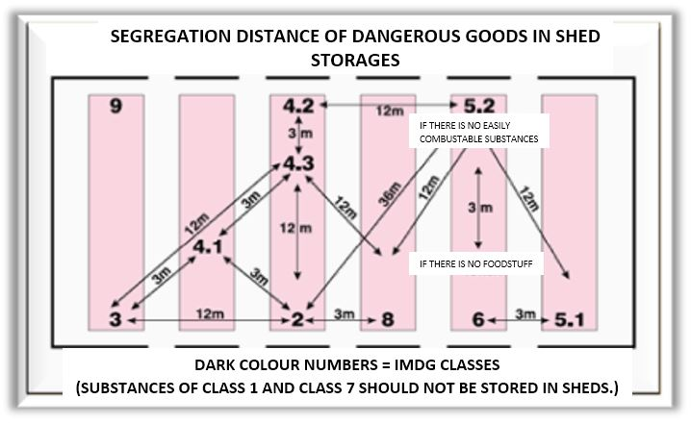

Terms used in Dangerous Goods Segregation in Shed Storages are as in Article 4.5.3.6.

Dangerous Goods Documents:

This part is examined in Article 7 of Documentation Chapter.

MANUAL FOR DANGEROUS CARGOES HANDLED ON SHORE FACILITY

Port facility which carries out loading/discharge, handling and temporarily storing of dangerous goods, contributes to make the activities in a safe condition;

- Dangerous goods classes,
- Dangerous goods packages,
- Packaging,
- Labels,
- Marking and packaging groups,
- Segregation tables for dangerous goods on board and port according to classes,
- Segregation distance of dangerous goods in sheds storages,
- Segregation terms,
- Dangerous goods documents,
- Dangerous goods emergency response action flowchart,

Are the same as in Dangerous Goods Manual Annex-10.

OPERATIONAL ISSUES

Procedures for berthing, mooring, loading/discharging, harbouring or anchoring of ships transporting dangerous goods at night and day in a safe condition:

- Ships transporting dangerous goods will be gone alongside to port berths by pilotage and tugboats preferably during day, during night if allowed by Port authority, in accordance with Port Regulations.
- Harbor Pilot will be informed about the dangerous goods aboard ship before maneuver.
- Positions of ship transporting dangerous goods must be considered, berthing must be planned after removal of ship in case of risk.
- In the event that practice of Master for mooring is deemed unsafe for port, it should be requested from Master to connect the ship by extra ropes.
- In case of unfavorable weather conditions, flows and winds create unsafe condition for loading/discharging, the activity must be stopped and the ships must be removed and taken to the anchorage.
- Anchorage sites are different for the ships transporting dangerous goods; ship can wait in the anchorage sites designated for them.

Procedures for additional measures taken for loading, discharging and transshipment of dangerous goods according to seasonal conditions.

- Seasonal conditions must be considered for loading and discharging of the dangerous goods. Handling flammable, combustible, explosive goods should be postponed or stopped at extreme heat, extreme cold, extreme rainy and weather with unfavorable sight conditions, lighting and weather with electric power load.
- If loading/discharging in unfavorable conditions have to be continued or in mandatory conditions; fire, fire department, emergency response teams must be kept in order to response to unwanted conditions as soon as possible.
- In case of continuity of similar conditions, measures, such as the workers must be elected from the experienced ones, resting periods must be planned frequently in extremely hard working situation, increase the lighting, etc. must be provided.

Procedures for keeping away flammable, combustible and explosive materials from spark producing operations and procedures for not operating vehicles, equipment and tools capable of spark-production in area of dangerous goods handling, stowing and storing are made.

- In dangerous cargo fields, while handling dangerous goods, working with especially flammable, combustible and explosive ;
- Not doing hot work (welding, cutting, etc), technical safety measures must be taken in case of mandatory cases,
- Ex proof hand tools must be used,
- Working with experienced personnel,
- Relevant units must be informed before work,
- Briefing will be given to the personnel working in the field,
- Especially in closed area of working, measurement of toxic, choking gases and sufficient oxygen must be done, the measurement device must be ready to use.
- Protective measures and equipment such as water curtain, protective separation, mechanical ventilation must be ready to use.
- The personnel working in HOT WORK must wear necessary protective clothing and equipment, closed circuit breathing apparatus when required.
- Emergency team must be assigned to response as soon as possible in potentially undesirable situation in this kind of working.

Procedures for fumigation, gas measuring and degassing.
- Fumigation, gas measurement, degassing of closed transport container will be made as follows:

- Covers of closed transport containers must be opened and ventilated well. Briefing must be given to the personnel who open the covers and they must be told clearly about flammable, explosive and toxic gases can be in container,
- If working will be inside the closed container, gas measurement control must be done.
- Measurement devices must be pre-tested, calibration must be done.
- Measurement in closed container, suspected as having toxic gas in, must be done by protective clothing and closed circuit breathing apparatus. .
- Measurement results must be recorded, available to show upon request.

It should be considered that there can be very small amount of gas, dust, granules, liquids, etc. left in closed transport container, and if different dangerous good is put into that container without the removal of the residues, these products can cause undesirable reactions.

DOCUMENTATION, CONTROL AND RECORD

7.1 Procedures related to all required documents, information and papers, their provision and control by the authorities.

The following documents related to Dangerous Goods are kept by Shore facility livingly.

- SOLAS 1974
- IMDG CODE Volume 1,2 ve ANNEX Book,
- IMSBC CODE, International Maritime Solid Bulk Cargoes Code
- International Agreement for Safety Container dated 1972 amended by CSC
- SSC Cargo Safety Connecting

In order to handle the dangerous goods transported to facility in a safe condition and to take the required measures, Shore facility needs documents sent prior. The documents are as follows:

    - Dangerous Goods Transport Document

Container/Vehicle Packing Certificate

Documents Required aboard ship

Other required documents and information

Multimodel Dangerous Goods Form

Dangerous Goods Transport Document:

Transport documents prepared by shipper, shall include “Signed Certificate or Dangerous Goods Transport Document” indicating that the consignment to be transported is properly packaged, marked and labelled and in proper condition for carriage in accordance with the applicable regulations.

Ships and sea vehicles transporting dangerous goods should present transport document involving the detailed information about the goods at least twenty four hours before entering the port administrative field; if the ship’s and sea vehicle’s journey time till port field is less than 24 hours, they will present them after departing from shore facility, to the Port authority in written for by responsible.

Those responsible for goods is obliged to report to the shore facility at least 3 hours before dangerous goods transported by road and railway are entered to the facility.

In case of failure to comply with reporting obligation or reporting does not involve correct information, administrative procedures can be made against the person who reports and they could lose their berthing, departing, passing order, if any.

When the dangerous goods transport document is given to a carrier by EDP (electronic data processing) or EDI (electronic data interchange), the shipper shall be able to produce the information without delay as a paper document, with the information in the sequence required by this chapter.

Dangerous Goods Transport Document can be in any form providing involving all information stated in Division 5.4 of IMDG Code.

Container/Vehicle packing certificate

When dangerous goods are packed or loaded into any container or vehicle, responsible for packing the container or vehicle must provide a ”container/vehicle packing certificate” specifying the container/vehicle identification number(s) and certifying that the operation has benn carried out in accordance with the following conditions:
- The container is clean, dry and apparently fit to receive the goods,
- Packages which need to be segregated in accordance with segregation requirements are not packed together and/or put into container/vehicles,
- All packages are externally inspected for damage, and only sound packages have been loaded,
- Drums are stowed in an upright position, unless otherwise indicated, and all goods are properly loaded and where necessary adequately braced with securing materials to comply with mode(modes) of transport of the intended journey,
- Goods loaded in bulk is evenly distributed within container/vehicle,
- The container/vehicle and packages are properly marked, labelled and placarded as appropriate,
- When solid carbon dioxide (CO2-dry ice) is used for cooling purposes, the container/ vehicle is externally marked regularly,
- Dangerous goods transport document, is received for each dangerous goods consignment loaded in the container/vehicle,

“Note: The container/vehicle packing certificate is not required for portable tanks.”

The information required in the dangerous goods transport document and the container/vehicle packing certificate may be incorporated into a single document; if not, these documents shall be attached one to the other. If the information is incorporated into a single document, the document shall include a signed declaration such as "It is declared that the packing of the goods into the container/vehicle has been carried out in accordance with the applicable provisions". This declaration shall be dated and the person signing this declaration shall be identified on the document.

If the dangerous goods documentation is presented to the carrier by means of EDP or EDI transmission techniques, the signature(s) may be electronic signature(s) or may be replaced by the name(s) (in capitals) of the person authorized to sign.

When the dangerous goods transport information is given to a carrier by EDP or EDI techniques and subsequently the dangerous goods are transferred to a carrier that requires a paper dangerous goods transport document, the carrier shall ensure that the paper document indicates "Original received electronically" and the name of the signatory shall be shown in capital letters.

Documentation required aboard the ship
Each ship transporting dangerous goods and marine pollutants on board shall have a special list, manifest or stowage plan regarding names and locations of dangerous goods and marine pollutants. This special list and manifest are based on documents and certificates requested in IMDG Code.
A detailed stowage plan, which identifies by class and sets out the location of all dangerous goods and marine pollutants, may be used in place of such special list or manifest.
For consignments of dangerous goods, appropriate information shall be immediately available at all times for use in emergency response to accidents and incidents involving dangerous goods in transport. The information shall be available away from packages containing the dangerous goods and immediately accessible in the occurrence of an incident. Information used in emergency response will be in the following documents:
- In a special list, manifest or dangerous goods declaration;
- In a separate document such as a safety data sheet;
- In separate documents such as Medical First Aid Guide for Use in Accidents Involving Dangerous Goods (MFAG) and Emergency Response Procedures for Ships Carrying Dangerous Goods (ES Guide) for use in conjunction with the transport documents.

Other required information and documents
In certain circumstances, special certificates or other documents are required as follows:
- A weathering certificate; as required in some entries of the Dangerous Goods List;
- A certificate exempting a substance, material or article from provisions of the IMDG Code (such as, see individual entries such as charcoal, fishmeal, seedcake);
- For new self-reactive substances and organic peroxides or new formulation of currently assigned self-reactive substances and organic peroxides, a statement by the competent authority of the country of origin of the approved classification and conditions of transport.

Multimodal Dangerous Goods Form
Multimodal Dangerous Goods Form is a form which is used as a combined dangerous goods declaration regarding transportation of dangerous goods in multiple modes and container packing certificate.
Example of Multimodal Dangerous Goods is in Annex-18.

7.2 Procedures for proper and full keeping updated list of dangerous goods in shore facility area and other information:

Port facility is obliged to submit the information about class, quantity, emergency response methods and locations of all dangerous goods in port facility, to the authorities upon request at any time.

Operation Department will keep the records involving the following information of the dangerous goods handled in our port.
- UN Number,
- PSN name ( Proper Shipping Name),
- Class, (Class 3, 4.1, 4.2, 4.3, 5.1, 6.1, 8, 9 with sub-dangers )
- Packing group (I; II; III)
- Marine Pollutant feature,
- Consignee,
- Shipper,
- Container / Packing number,
- Seal number,
- Additional Information (Ignition temperature, viscosity, etc. )
- Storage Location in Port Field
- Duration of stay in Port

This information is kept under computer or file as only reached by authorized personnel, shown upon request.

Port facility keeps the updated records of dangerous goods about class, quantity, which have been handled throughout the year by the port and notifies them to Port authority in 3 months period.

Procedures for control of proper identification of dangerous goods in the facility, using proper shipping names, certificating, packaging/packed, labeling and declaring of dangerous goods, loading to approved package, container or good cargo transport unit in accordance with rules and transporting in a safe condition and reporting the results of control.

Planning department checks the accuracy of the following information on dangerous goods documents issued by the shipper in coordination with operation about the dangerous goods to be received to port;
- UN Number,
- PSN name (Proper Shipping name),
- Class, (Class 3, 4.1, 4.2, 4.3, 5.1, 6.1, 8, 9 with sub-dangers)
- Packing Group ( I; II; III)
- Marine Pollutant feature,
- Container / packing number,
- Seal number,
- Additional information (Ignition temperature, viscosity, etc.)
- Storage Location in Port Field,

This information is delivered to the tally clerk, Field Supervisors, Storage officers, HSE and to the staff who requires knowing the information, by sending upon terminals/documents, so the control of dangerous goods is provided.
In the event that information from operation conflicts with information of goods, operation shall be informed immediately, shipper is directed to confirm the information dangerous goods cargo/vehicle/container, correct the deficient and wrong label marks if any.

Procedures for obtaining and keeping dangerous goods safety information form(SDS).

Dangerous Goods Safety Information Form (SDS) involving the following information is required for dangerous goods transported by all modes of transportation (Road, rail, air and marine) according to our national law since 1 January 2014.
- UN number,
- PSN (Proper shipping name,) (required for marine transport. )
- Class, (Class 3, 4.1, 4.2, 4.3, 5.1, 6.1, 8, 9 with sub-dangers)
- Packing group (I; II; III)
- Marine pollutant feature,
- Tunnel Restriction Code (required for road transport. )

In port, there is a check to control this document together with the dangerous goods to be received.

Procedures for keeping records and statistics of dangerous goods.

ADMINISTRATION requests to give a report involving the information of dangerous goods, handled in our Port facility, to Port Authority in 3 month-periods. The example of the report issued by Operation Department is below.
Statistical evaluation from records of dangerous goods handled in our port annually is prepared by trade, operation departments.
Monthly inventory and control reports of dangerous goods stored in the port are issued by operation department and submitted to the Management.
Records and reports are archived by the departments in 5 year periods.

EMERGENCIES, PREPAREDNESS FOR EMERGENCİES AND RESPONSE

Response procedure for dangerous goods that endangers/able to endanger life, property and/or environment and dangerous incidents involving dangerous goods:

Dangerous goods received, handled, stored, loaded and discharged to shore facility, can create unique hazards such as explosion, fire, corrosion, poisoning, infectious diseases, radiation. Therefore there are emergency varieties of shore facility could face. In order to cope with these dangers, it’s extremely important develop, announce and apply the Emergency Plan that’s formed in cooperation with local emergency teams.

The following issues required to be considered to form emergency strategy in shore facility.

- Preventing accidents,
- Preparing Emergency Plan,
- Implementation and Exercise of Emergency Procedures,
- Checking emergency equipment regularly,
- Implementation of plan in occurrence of emergency,
- Analyzing and reporting the incident to prevent the repetition,

The procedures to be followed in order to prevent accidents are as follows.
- The primary parameter of preventing accident is training. All shore facility employees must know safety rules and regulations, be trained about handling dangerous goods and always follow the rules and regulations formed.
- Personnel in charge of recording and documenting procedures must always keep the dangerous goods information system of port updated and accurate. Receiving cargoes must be added to the system and remove the information of the goods which are exited, from main system and back up.
- Smoking is not allowed in the locations where dangerous goods are handled or stored in order to prevent explosion and/or fire.
- Workers handling goods should not eat or drink anything due to the risk of poisoning while working.
- Dangerous goods must be checked regularly to detect leakage, packaging damage, deterioration and temperature changes.

Procedures to be followed regarding to reparation of Emergency Plan are as follows.
- First, a response system must be formed, in case of accident person who realized the accident must be informed about contacting how/who (phone, radio, alarm sounds, hand signals) and the kind of information to be delivered.
- It should be determined that who will be responsible about each stage of emergency procedures.
- Emergency plan must be prepared by making a detailed classification of possible activities to carry out against all kind of emergencies such as fire, leakage, injuries.
- A certain responsibility and command chain must be established from the personnel in emergency control center to the person in the location of incident.
- Emergency plan and procedures which are agreed on and confirmed, must be published and delivered to managers, practitioners and supervisors and everybody in the system must be informed about their roles.
- An effective information system must be formed in order to record and investigate the incident and take lesson.
- Establishment of emergency plan is as follows.
Training of Emergency Response Team
Creating Procedures for Periodic Control and Revise
Evaluating of Risks and Dangers in Different Emergencies
Defining of Required Response
Determining duties, sources and communication principles pf response team
Improving Current Plans and taking them into system
Preparing the Final Plan providing the compliance with Shore facility &Ship Plans

- Emergency equipment must be located at strategic points in the port. (protective clothing packs, face masks or goggles, respiratory equipment, other materials to clean sand or running/spilling substances).
- Emergency storages must be clearly stated and marked on layout plan of shore facility, copies must be distributed to all employees.
- Local Emergency Teams must join emergency plan preparation and close contact system between shore facility management and firefighters, police, ambulance services and hospitals in the region.
- Emergency service team in region of shore facility is important for each accident except the minor accidents. Therefore plan and procedures must be planned according to the regional service capacity.
- If there are important dangerous goods shippers; they should be included to Emergency Plan.

Implementation and Exercise of Emergency Procedures:

- The main part of emergency system is implementation of procedures regularly in a conscious way as planned.
- Emergency teams must be established from employees in each department and unit of shore facility, these teams must be trained with regular exercise and exercise lessons.
- Local emergency services (firefighters, ambulance service, etc.) must be involved in these exercises. ( it’s important as they know the geographical characteristics of port)

Checking emergency equipment regularly:

The following emergency equipment must be checked regularly and frequently, maintenance and repair must be done.
- Fire hoses and fire extinguishers.
- Sets of protective clothing, boots, goggles, eye showers, etc.
- First aid boxes,
- Emergency communication devices,
- Signposts and access to all kinds of emergency service points ,

Occupational safety manager, also all personnel of shore facility, is responsible for control, maintenance and repair of emergency equipment.

Implementation of Plan when emergency occurs:

In case of emergency, the plan will be implemented as follows.

- The person, who notices the accident, shall inform facility’s operating center or emergency control center immediately by using designated communication systems.
- Emergency control center stops all operations around accident.
- Emergency control center sends the nearest inspector to the incident scene. The inspector evaluates the situation.
- Emergency control center makes the required inspection to determine the conditions of dangerous goods and the dangers arising from dangerous goods in the dangerous goods information system.
- If inspector informs the accident as serious, emergency control center instructs everyone to leave the area and isolates the area of incident by using barriers.
- All emergency teams, security, first aid teams, ambulance and fire systems are sent to the incident scene.
- Shore facility teams response the incident, responding team may have to transport goods or injured people from the incident scene to a safe area as fast as possible.
- If the incident is large-scaled, emergency control center calls the local emergency services by using predetermined communication system and giving detailed information of incident.
- When local emergency teams arrive to incident scene, copies of dangerous goods are given to them and they will be accompanied to the incident scene.
- Local emergency services take action and make the incident scene safe.
- Emergency control center contacts with and informs the shipper, ship agency or other responsibles and consult them for treating and removing the damaged cargo. Also it contacts with dangerous goods advisor.
- In case the first aid is insufficient in incident scene, injured person is sent to infirmary of facility or hospital in the region.
- Damaged cargo and packaging and/or container are carried to a safe area by removing immediately if secure. Incident scene is cleaned by absorbents, chemical foams or water properly. Marine pollutants and other dangerous goods are put in a pit designated for it.
- After explaining the accident scene is safe, emergency control center instructs to start the operations again.

Analyzing and reporting to prevent the repetition of incident:

- After the incident, the background and reasons should be investigated, it should be reported to the relevant authorities by using proper reporting system.
- Shore facility should evaluate the response to incident in terms of speed, accuracy and efficiency, required changes and adjustments should be done for response to future accidents.

In our shore facility, BP Gemlik Emergency Action Plan is implemented, all facility employees will perform their duties stated in the plan when emergency occurs.

Information for possibility, capacity and capability of shore facility to response emergencies.

Possibility, capacity and capability to response fire :

- Fire water line with thickness of 6 inches and double sleeved, German Storz type output fitting, water outlet openings in 3 different points on this line,
- Hose cabinets with laying hoses next to water outlet openings,
- Water and foam monitor on the jetty,
- Foam car and manual foam materials (Foam Concentrate, Melange, Foam Lane. C type fire-fighting hose)
- 2 pieces capacity of m³/h, 1piece capacity of 30 m³/h and 1 piece capacity of 90 m³/h electric fire pumps (generator assisted)
- 2 pieces ABC Dry Chemical Powder fire extinguisher with 50 kg,

Possiblity, capability and capacity against leakage and spillage.

Barriers |  | Storage Capacity |  | Pressure Water Washer | Absorbent Barrier and Pads |  | Cleaning Company contracted and contact information | Sea Vehicles fighting against marine pollution
Inflamatable Barrier ( m ) | Fence Barrier ( m ) | Store on Land  (m³) | Temporary Store on sea (m³) | Features | Absorbent Barrier ( mt. ) | Absorbent Pad  ( Piece)
 | 250 | 40 |  |  |  | 100 | Başaran Gemi Onarım Müh. Ltd.Şti Bağdat Cd.Çiçek Sk.No:12/5 Güzelyalı / İstanbul Phone : 0 216 392 41 43 | 1-Başaran - 1  2-Başaran - 2  3-Mavideniz-2

Regulations on first aid for accident involving dangerous goods

Medical first aid guide (MFAG) will be used for the accidents involving dangerous goods.Issues taken into consideration for use of this guide are stated below.

- In any case of exposure to dangerous goods, firstly emergency response will be applied.
- Medical first aid guide will be applied in 3 steps.

1.Step : Emergency Action and diagnosis Start here!

2.Step : Consider tables. The tables give brief instructions for special circumstances.

3.Step : Consider appendices The Appendices provide comprehensive information, medicines and chemicals that might be exposed.

Use the following table while emergency action.
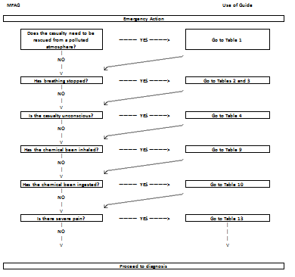

Use the following table for diagnosis .
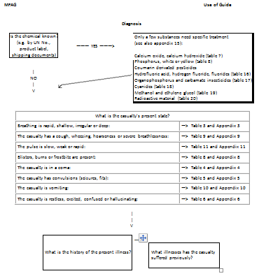

Tables involves special conditions for special conditions, the information for tables are as follows.

Table 1 : Rescue
Table 2 : Cardio-Pulmonary Resuscitation (CPR)
Table 3 : Oxygen Administration and Controlled Ventilation
Table 4 : Chemical-Induced Distrubances of Consciousness
Table 5 : Chemical-Induced Convulsions
Table 6 : Toxic Mental Confusion
Table 7 : Eye Exposure to Chemicals
Table 8 : Skin Exposure to Chemicals
Table 9 : Inhalation of Chemicals
Table 10: Ingestion of Chemicals
Table 11: Shock
Table 12: Acute Kidney Failure
Table 13: Pain Relief
Table 14: Chemical-Induced Bleeding
Table 15: Chemical-Induced Jaundice
Table 16: Hydrofluoric Acid and Hydrogen Fluoride
Table 17: Organophosphate and Carbamate Insecticides
Table 18: Cyanides
Table 19: Methanol and Ethylene Glycol
Table 20: Radioactive Material

The Appendices provide comprehensive information, medicines and chemicals that might be exposed. Information on appendices are as follows.

Appendix 1 : Rescue
Appendix 2 : Cardio-Pulmonary Resuscitation (CPR)
Appendix 3 : Oxygen Administration and Controlled Ventilation
Appendix 4 : Chemical-Induced Distrubances of Consciousness
Appendix 5 : Chemical-Induced Convulsions
Appendix 6 : Toxic Mental Confusion
Appendix 7 : Eye Exposure to Chemicals
Appendix 8 : Skin Exposure to Chemicals
Appendix 9 : Inhalation of Chemicals
Appendix 10: Ingestion of Chemicals
Appendix 11: Shock
Appendix 12: Acute Kidney Failure
Appendix 13: Pain Relief
Appendix 14: List of Medicine and Equipment
Appendix 15: List of Materials

Notification to be made inside and outside of facility in emergencies.

Flowchart for notification to be made in emergencies are as follows.

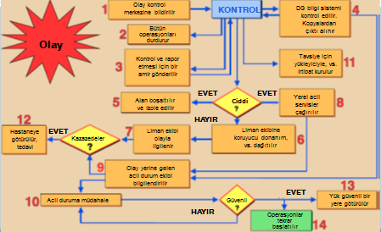

Notifications required to be made in our shore facility is the same as in Emergency Evacuation Plan.

Procedures for reporting accidents.

Accidents/incident involving dangerous goods, which occurred in our facility, shall be reported to Port authority no later than 3 hours after incident by VHF radio or other communication tools primarily. After this notification, a written report involving statements about accident/incident shall be sent to port authority within 24 hours.

Coordination, support and cooperation method with public authorities.

Coordination, support and cooperation method with public authorities is the same as in Emergency Action Plan.

Emergency evacuation plan for ship and sea vehicles from shore facility in emergencies.
Acting in accordance with the principles of Emergency Evacuation Plan submitted to Port authority.

Procedures for handling of damaged dangerous goods and wastes contaminated by dangerous goods and disposal of them.

Each dangerous goods handled in our facility has “Dangerous Goods Safety Information Form (MSDS).In the stated forms, damaged dangerous goods, handling wasted contaminated by dangerous goods and their disposal will be carried out by taking into consideration of issues in MSDS forms.

Emergency drills and their records:

Training required to be taken by people in charge of dangerous goods operations will be implemented as indicated below.

Each person engaged in transport or handling of dangerous goods should take training for transport or handling of dangerous cargo in a safe condition commensurate with their responsibilities.

Shore-based personnel, should take training general awareness/familiarization training, function-specific training and safety training. These people could be stated as follows:

Classifying the dangerous goods and identifying the Proper Shipping Names of Dangerous goods;

Packing the dangerous goods ;

Marking or labelling the dangerous goods;

Opening/closing the packages of cargo transport units;

Preparing transport documents for the dangerous goods;

Offering the dangerous goods for transport;

Receiving or taking the dangerous goods for transport;

Handling the dangerous goods on transport;

Preparing the plans for loading/stowage the dangerous goods;

Loading/discharging the dangerous goods into/from ships;

Carrying the dangerous goods in transport;

Inactivating the cargo storages;

Measuring the cargo storage and taking samples;

Washing the cargo storages in accordance with approved procedures and regulations;

Enforcing, surveying or inspecting legal requirements, rules and the compliance with regulations

Involving in any other way into the transport of dangerous goods as determined by Competent Authority.

The content of training required for people engaged in dangerous goods is as follows.

General awareness / familiarization training:

Each person should take training for safe shipment or handling of dangerous cargo commensurate with responsibilities. Training must be designed to ensure the familiarization of general dangers and legal requirements of dangerous cargoes. This training must involve identification of types and classes of dangerous cargoes, labelling, marking, packaging, segregation and compliance with requirements; a description of purpose and content of dangerous goods transport documents and a description of available emergency response documents.

Function-specific training:

Each person shall be trained in specific dangerous goods transport provisions about the safe shipment or handling of dangerous cargo which is applicable to the function that person performs.

Safety training:

Each person should receive training about the following issues regarding risks in the occurrence of a release of dangerous cargoes and the function performed:

- methods and procedures for accident avoidance about proper use of package handling equipment and appropriate methods of stowage and segregation of dangerous goods;

- available emergency response information and how to use it;

- general dangers presented by the various types and classes of dangerous goods and how to prevent exposure to those hazards, including, if appropriate, the use of personal protective clothing and equipment; and

- emergency procedures to be followed in the event of an unintentional release of dangerous goods, including any emergency response procedures for which the person is responsible and personal protection procedures to be followed.

Records regarding the training of people in charge of dangerous goods:

Records of all safety training received must be kept by Port Facility, and made available to the employee upon request.

Drills and record regarding to dangerous goods.

- Drill implementation ; In order to be ready for emergencies in facility, personnel in emergency organization are prepared for their duties by various training. Trainings must be done by support of specialized organization when necessary. In this context, relevant personnel get IMDG code training regarding to dangerous goods and certificated in the port. It should be planned to carry out and implement the drills according to the worst-case scenario in order to test the adequacy of emergency plans and be ready for real incidents.
- Drill Scenarios; The worst scenario must be foreseen as one incident or a combination of incidents faced by port in exercise planning. Exercises are provided to implement in line with prepared scenarios in fastest and most efficient way.
- Emergency Drills to be held within port facility;
- It should be stated in Port annual training plans.
- IT can be planned as local or general response,
- It can be combined with Safety, Spilling, etc exercise scenarios,
- Drills can be made by/without informing.
- Drills are based on various emergency scenarios.
- Drills can be made actually, or desk bound, seminar type,
- Scenarios with different time, day, season and incident are prepared for each drill.

Information on fire protection system.

There are fire cabinet, hydrants, fire monitor, fire station, foam room, portable fire extinguishers and fire alarm buttons under fire protection systems in our facility. Information on fire protection systems is the same as in Article 8.2.1.

Procedures for approval, inspection, test, maintenance of fire protection system and keeping ready to use it.

Approval from Kocaeli Metropolitan Municipality Fire Department Directorate is taken for approval and inspection of fire protection system in our facility.

Test, maintenance of fire protection system and keeping it ready to use are carried out by our facility.

Measures to be taken when fire protection system not working.

When the fire protection system does not work in our facility, primarily the facilities of adjacent facilities shall be tried to be used, then local fire department will be informed. Response to incident will be made by using all capacity of the region.

Other risk controlling equipment.

There is no other risk control equipment available.

OCCUPATIONAL HEALTH AND SAFETY

Occupational Health and Safety Measures:

The purposes of the occupational health and safety are as follows;
- To protect employees:
It is the main purpose of the occupational health and safety. It aims to protect the employees against working accidents and occupational diseases, provide the mental and physical integrity.
- To provide production safety:
It is important for economy as providing production safety in workplace will lead an increase in efficiency.
- To provide facility safety:
As the measures taken in workplace remove the dangers in facility due to machinery malfunctions and disabled operations, explosions, fire which may arise from working accidents or unsafe and unhealthy working conditions, the facility safety can be ensured.

Measures stated in “Occupational Health and Safety Manual” issued under Occupational Health and Safety are considered in our facility.

Information for personal protective clothing and procedures for using them:
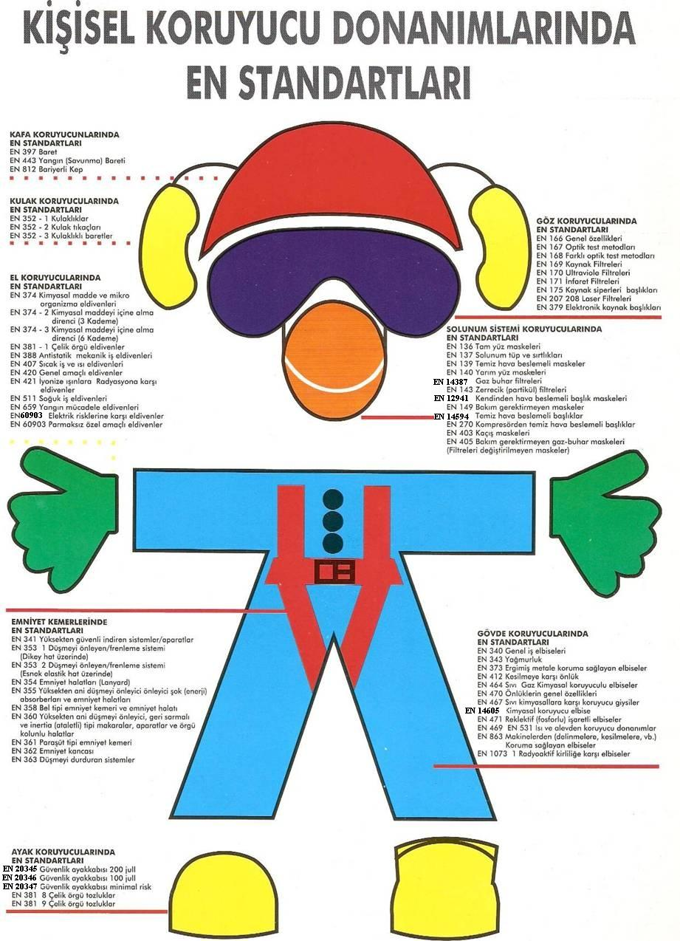
Personal protective clothing have the standards mentioned in the figure, the table showing which cloths will be worn by whom is stated in Appendix 15.
EN STANDARDS FOR
PERSONAL PROTECTIVE EQUIPMENT
EN STANDARDS FOR
BODY PROTECTORS
EN 340 General working cloths
EN 343 Raincoats
EN 373 Protective clothing against molten metal
EN 412 Aprons against cuts
EN 464 Liquid Gas chemical protective clothings
EN 470 General specifications of aprons
EN 467 Protective clothing against liquid chemical
EN 14605 Chemical protective clothing
EN 471Protective clothing with reflective marks
EN 469 EN 531 Protective equipment against heat and flame
EN 863 Protective clothing against machine (from puncture, cutting etc.)
EN 1073 Protective clothing againt radioactive pollution

EN STANDARDS FOR
RESPIRATORY SYSTEM PROTECTIVE DEVICES
EN 136 Full face masks
EN 137 Respiratory tubes and backplates
EN 139 Fresh air supply masks
EN 140 Half face masks
EN 14387 Gas vapour filters
EN 143 Particle filters
EN 12941 Air Self-supply helmet masks
EN 149 Maintenance free masks
EN 14594 Fresh air supply masks
EN 270 Fresh air supply from compressor masks
EN 403 Escape masks
EN 405 Maintenance-free Gas-vapour masks (filters of masks are not changed)

EN STANDARDS FOR
EYE PROTECTORS
EN 166 General specifications
EN 167 Optical test methods
EN 168 Different optical test methods
EN 169 Filters for welding
EN 170 Ultraviolet filters
EN 171 Infrared filters
EN 175 Face protection for welding helmet
EN 207 208 Laser filters
EN 379 Electronical welding filters helmet

EN STANDARDS FOR
FOOT PROTECTORS
EN 20345 Safety footwear 200 jull
EN 20346 Safety footwear 100 jull
EN 20347 Safety footwear minimal risk
EN 381 8 Steel netting leggings
EN 381 9 Steel netting leggings

EN STANDARDS FOR
SAFETY BELTS
EN 341 Systems/apparatus against falls from a height in a safe condition
EN 353 1-Fall arresters/braking systems (on vertical line)
EN 353 2- Fall arresters/braking systems (on flexible elastic line)
EN 354 Safety ropes (Lanyards)
EN 355 Shock (Energy) absorbers against falls from a height and lanyards
EN 358 Waist type safety belts and lanyards
EN 360 Protective equipment against falls from a height-retractable type fall arresters and inertia pulleys, apparaturs and netting ropes
EN 361 Parachute type safety belts
EN 362 Safety hook
EN 363 Fall protection systems

EN STANDARDS FOR
HAND PROTECTORS
EN 374 Protective gloves against chemicals and micro-organisms
EN 374-2 Resistance to penetration by chemicals (3 stages)
EN 374-3 Resistance to penetration by chemicals (6 stages)
EN 381-1 Steel wnetting gloves
EN 388 Antistatic mechanical protective gloves
EN 407 Hot work and thermal gloves
EN 420 General purpose gloves
EN 421 Protective gloves against ionizing beams and radiation
EN 511 Cold work gloves
EN 659 Protective gloves for firefighting
EN60903 Protective gloves against electrical risks
EN 60903 Special purpose mitts

EN STANDARDS FOR
HEARING PROTECTORS
EN 352-1 Ear Muffs
EN 352-2 Ear Plugs
EN 352-3 Helmet with Ear Muffs

EN STANDARDS FOR
HEAD PROTECTORS
EN 397 Helmet
EN 443 Fire (Defense) Helmet
EN 812 Bump Cap

OTHER ISSUES

Validity of Dangerous Goods Compliance Certificate.

(PUT WHEN ISSUED BY ADMINISTRATION.)

Duties defined for Dangerous Goods Safety Advisor.

Monitoring compliance with requirements about carriage of dangerous goods.

Offering suggestions to shore facility about carriage of dangerous goods.

Preparing an annual report to shore facility about the activities of shore facility operator for carriage of dangerous goods. (Annual reports are kept for 5 years, submitted to the authorities on request.)

Controlling the following application and methods;

Controlling of identifying, using the proper shipping name, certificating, packing/packaging, labelling and declaring of dangerous goods, loading and transporting to the approved and appropriate packs, container and cargo transport units in a safe condition , and procedures for reporting control results.

Procedure for loading/discharge of dangerous goods handled and stored temporarily,

Whether taking into consideration of special requirements of shore facility about dangerous goods while buying the transport vehicles regarding to handled dangerous goods,

Control methods of equipment used for transporting, loading and discharging the dangerous goods,

Whether the shore facility personnel take appropriate training including the amendments in legislation, and whether the records are kept or not,

Compliance of emergency methods applied in case an accident or incident that affects safety during transporting, loading or discharging dangerous goods,

Compliance of reports prepared for serious accidents, incidents or serious violations occurred during transporting, loading or discharging dangerous goods,

Determination of required measures against repetition of accidents, incident or serious violation and evaluation of the implementation,

To what extent, considering rules about selection of subcontractors or third parties and dangerous goods carriage,

Determination whether the employee working in transporting, handling, storing and loading/discharging of dangerous goods, have detailed information about operational procedures and instruction,

Compliance of measures taken to be prepared for risks during transporting, handling, storing and loading/discharging of dangerous goods,

Procedures for what the required document, information and papers related to dangerous goods.

Procedures about berthing, mooring to shore facility, loading/discharging, harbouring or anchoring for ships transporting dangerous goods by day and at night.

Procedures about additional measures for loading, discharging and transshipment according to seasonal conditions.

Procedures about fumigation, gas measuring and degassing, Procedures keeping records and statistics of dangerous goods,

Accuracy of information about ability, capacity and capability of shore facility for emergency response,

Compliance of regulations for first response to the accidents involving dangerous goods,

Procedures for handling and disposal of the damaged dangerous goods, wastes contaminated with dangerous goods,

Information about personal protective clothing and procedures for using them.

Issues for carrier of dangerous goods to the shore facility /from the shore facility by land (documents to be kept by road vehicles during entrance/exit of port or shore facility field, equipment and tools kept by these vehicles; port field speed limits, etc.):

Documents required to be carried:

- Transport documents,
- Dangerous goods Transportation Driver Training Certificate (SRC-5),
- Identification card with photo in charge in vehicle (identity card, driving license or passport),
- Written instruction prepared by carrier to give to driver ,
- Multimodal Dangerous Goods Transportation Form for dangerous goods transported in multimodals,
- ADR conformity certificate for vehicles,
- Copy of transport permission document taken from related competent authority for Class1, class 6 and class 7 dangerous goods transportation,
- Dangerous Goods and Dangerous Waste Compulsory Financial Liability Insurance for vehicles carried out dangerous goods transportation,

Equipment and apparatus required to have in vehicles:

- Portable fire extinguishers,
- At least one chock of appropriate size to the wheel diameter and maximum mass for each vehicle,
- Two self-standing warning signs,
- Eye rinsing liquid,
- Warning vest,
- Portable lightening apparatus,
- A pair of protective gloves,
- Eye protection goggles,
- Emergency escape mask,
- Shovel,
- Drain seal,
- Collecting container

Speed limits in Port Area:

Speed limits determined by Port facility will be applied.

Issues regarding to the carriers of dangerous goods to coming the shore facility/leaving from shore facility by sea (exhibition of signals by ships and sea vehicles to the port or shore facility by day/at night, cold and hot working procedures aboard ship)

Exhibition of signals by ships and sea vehicles to the port or shore facility by day/at night:

The ship which arrives to port and carries dangerous goods will have “B” (Bravo) international code of signals by day, an all-round fixed red light by night.

Cold and Hot Work procedures aboard ships in the shore facility and carrying dangerous goods:

The ships carrying dangerous goods and staying in shore facility shall take the required permission for hot and cold work from Port authority and inform the shore facility responsible.

The procedures for hot work to be carried out in ships carrying dangerous goods in tha shore port are as follows.

- Before starting any hotwork in shore facility, the responsible person of the company to carry out the hotwork must be in possession of written authorization to carry out such hot work issued by the Port Authority. Such authorization shall include details of specific location of the hot work as well as safety precautions.
- In addition to the safety precautions required by the Port Authority, before starting any hotwork, the responsible person of the company to carry out the hot work together with responsible person(s) of the ship and/or berth, shall add any additional safety precautions required by the ship and/or berth . These additional safety precautions shall include:
- Examination of local areas and adjacent areas, including tests to ensure the areas are free, continue to be free, of flammable and/or explosive atmosphere and where appropriate not deficient in oxygen,
- The removal of dangerous cargoes and other flammable substances and articles away from the working and adjacent area.
- Efficient protection of flammable structural members such as beams, hatches, walls and ceiling coverings against accidental ignition;and

- The sealing of open pipes, pipe lead through, valves, joints, gaps and open parts to prevent the transfer of flames, sparks and hot particles from working areas to adjacent or other areas.
- A duplicate of the hot work authorization and safety precautions shall be posted adjacent to the work area as well as at each entrance to the work area. The authorization and safety precautions shall be readily visible to, and clearly understood by all persons in charge of hot work.
  - While carrying out hot work, it is essential that checks are carried out to ensure that conditions have not changed; and at least one suitable fire extinguisher or other suitable fire extinguishing equipment is readily available for immediate use at the location of the hot work.
  - During hot work and after completion of such work, an effective monitoring shall be maintained for a sufficient time in the area of hot work as well as adjacent area where a danger causing from the transfer of heat may be created.

Additional issues added by shore facility.

None.

ANNEXES

ANNEX-2
PHOTO OF GENERAL APPEARANCE OF SHORE FACILITY

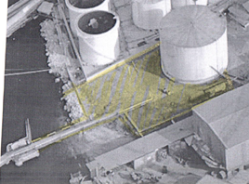
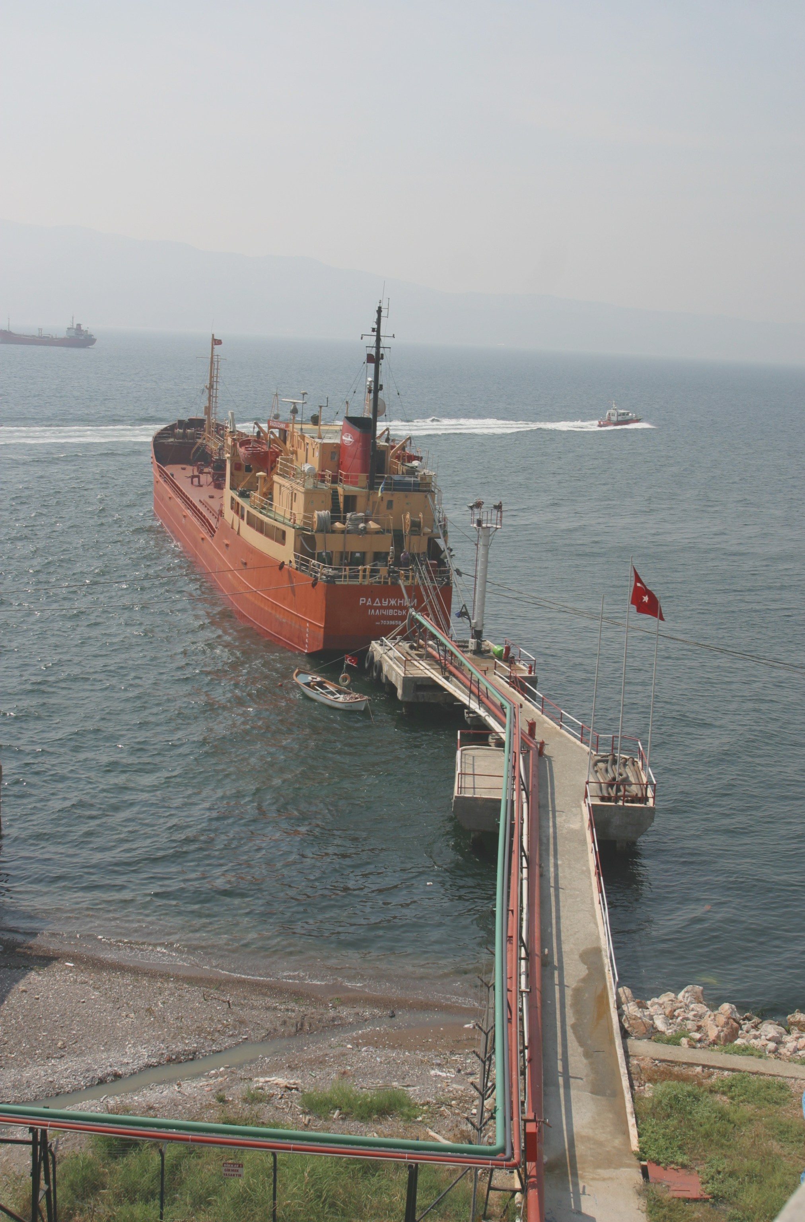

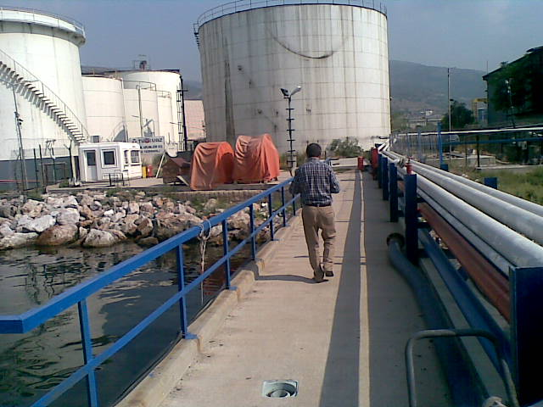

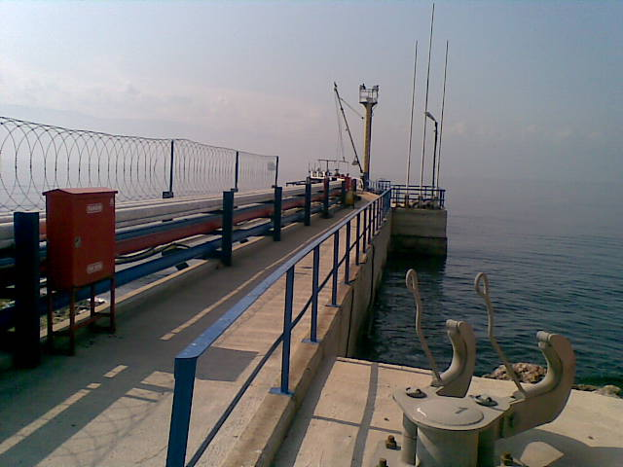
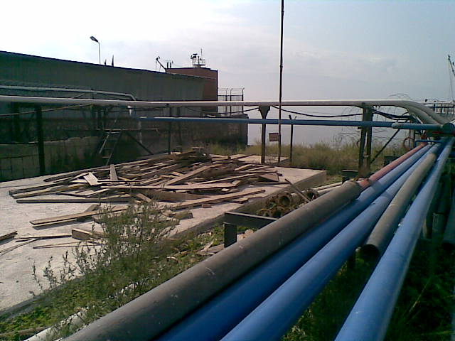

ANNEX-3
EMERGENCY CONTACTS AND CONTACT INFORMATION

Ministry of Transport, Maritime Affairs and Communications-Dangerous Goods and Combined Transportation Regulation General Directorate
Phone: (0312) 203 20 00 | Fax : (0312) 231 51 89
 | Ankara
Main Rearch and Rescue Coordination Centre
Phone: (0312) 231 91 05 (24 saat)  (0312) 232 47 83 (24 saat) | Fax : (0312) 232 08 23
e-mail: trmc@udhb.gov.tr | Ankara
Shore Securtiy General Directorate
Phone: (0212) 252 22 94 | Fax : (0212) 292 52 97
Phone: (0212) 252 22 94 | İstanbul
Kocaeli Harbour Master
 | Fax : (0262) 528 51 04
  Phone: (0262) | 528 37 54
 | Kocaeli
Körfez Governorship
Phone: (0262) 528 85 49 | Fax : (0262) 528 88 17
Phone: (0262) 528 85 49 | Kocaeli
North Sea Area Command
Phone: (0212) 254 31 50
Phone: (0212) 254 31 50 | İstanbul
Coast Guard Marmara and Straits Region Command
Phone: (0212) 242 40 00 |  | Fax : (0212) 242 30 93
 |  | İstanbul
Provincial Disaster Emergency Management Center
Phone: (0262) 321 10 29/  (0262) 321 26 25/324 97 30 | Fax : (0262) 321 81 81
Phone: (0262) 321 10 29/  (0262) 321 26 25/324 97 30 | Kocaeli
Kocaeli Province Police Department
Phone: (0262) 315 72 72 | Fax : (0262) 239 39 71
0505 318 41 00 – 01 | Kocaeli
Körfez Mayorship
Phone: (0262) 528 23 02 | Fax : (0262) 528 54 22
 |  | Kocaeli
Körfez District Police Department
Phone: (0262) 528 15 82 | Fax : (0262) 528 56 66
 | Kocaeli
Körfez State Hospital
Phone: (0262) 526 66 66 | Fax : (0266) 526 66 64
Phone: (0262) 526 66 66 | Kocaeli
Derince Training and Research Hospital
Phone: (0262) 317 80 00/233 54 90 | Fax : (0262) 233 55 40
 | Kocaeli
Kocaeli Seka State Hospital
Phone: (0262) 325 33 16/  (0262) 322 34 60-69 | Fax : (0262) 321 21 82
Phone: (0262) 325 33 16/  (0262) 322 34 60-69 | Kocaeli
Fire Department | 110
Emergency Service | 112
Coast Guard Alarm | 158
Police | 155
Gendarme | 156
Phone Fault | 121
Electrical Fault | 186
Water Fault | 185
Natural Gas Fault | 187

ANNEX-7
EMERGENCY ACTION PLAN

SAME AS IN EMERGENCY RESPONSE PLAN OF TURKUAZ IZGIN TERMINAL

7-1

ANNEX-9
EMERGENCY MANAGEMENT PLAN

Emergency Manager

Secretary
Emergency Management Group

Response Department

Finance Department

Technical Team

Logistics Department

Search-resque Team

Planning Department

Social Support Team

Damage Assessment Team

First Aid Team

Fire Team
Evacuation Responsibles

Security Department

Meeting Area Responsibles

Chemical Leakage Team

9-1

ANNEX-10
DANGEROUS GOODS MANUAL

ANNEX-12
INVENTORY OF PORT SERVICE SHIPS

THERE IS NO SERVICE SHIP IN FACILITY INVENTORY.

12-1

ANNEX-13
PORT AUTHORITY ADMINISTRATIVE BOUNDARIES, ANCHORING LOCATIONS AND HARBOR PILOT, MARINE COORDINATES OF LANDING/BOARDING POINTS

- Port administrative area boundary
Port administrative area of Kocaeli Harbour Master is sea and shore zone within the lines formed by the following coordinates.
a) 40° 45' 24" K – 029º 21' 15" D (Yelkenkaya Cape)
b) 40° 43' 00" K – 029° 21' 18" D
c) 40° 43' 00" K – 029° 23' 24" D
d) 40° 44' 57" K – 029° 30' 57" D
e) 40° 44' 48" K – 029° 32' 30" D
f) 40° 41' 12" K – 029° 33' 36" D
B) Anchoring areas
a) İzmit anchoring area: Anchoring area for ships not transporting dangerous goods is the sea area consisting the following coordinates.
1) 40° 45' 00" K – 029° 52' 48" D
2) 40° 44' 00" K – 029° 52' 48" D
3) 40° 44' 00" K – 029° 55' 00" D
4) 40° 45' 00" K – 029° 55' 00" D
b) Yarımca anchoring area: Anchoring area for ships transporting dangerous goods, military ships powered by nuclear and quarantined anchoring area is the sea area consisting the following coordinates.
1) 40° 46' 24" K – 029° 41' 00" D
2) 40° 45' 09" K – 029° 41' 00" D
3) 40° 44' 54" K – 029° 43' 00" D
4) 40° 46' 18" K – 029° 43' 00" D
c) Hereke anchoring area: Anchoring area for ships which do not transport dangerous goods is the sea area consisting the following coordinates.
1) 40° 46' 36" K – 029° 38' 09" D
2) 40° 45' 24" K – 029° 38' 09" D
3) 40° 45' 12" K – 029° 40' 30" D
4) 40° 46' 27" K – 029° 40' 30" D
ç) Eskihisar anchoring area:Anchoring area for ships which do not transport dangerous goods is the sea area between the line connecting the following coordinates and coastline in the north of this line. In this area, no anchoring will be made within the distance of 2,5 gomino from the shore.
1) 40º 45' 12" K – 029º 23´ 27" D (Darıca Cape)
2) 40º 46' 00" K – 029º 30´ 57" D (Kaba Cape)

ANNEX-14
EMERGENCY RESPONSE EQUIPMENT AGAINST MARINE POLLUTION IN PORT FACILITY

Bariyerler |  | Depolama Kapasitesi |  | Basınçlı Su Yıkayıcısı | Emici Bariyer ve Pedler |  | Anlaşma Yaptığı Temizlik Firması ve İletişim Bilgileri | Denizde meydana gelen Kirlilikle mücadele edecek deniz Araçları
Şişme Bariyer ( m ) | Çit Bariyer ( m ) | Karadaki Depo  (m³) | Denizde Geçici Depo (m³) | Özelikleri | Emici Bariyer ( mt. ) | Emici Ped  ( Adet )
 | 250 | 40 |  |  |  | 100 | Başaran Gemi Onarım Müh. Ltd.Şti Bağdat Cd.Çiçek Sk.No:12/5 Güzelyalı / İstanbul Tlf : 0 216 392 41 43 | 1-Başaran - 1  2-Başaran - 2  3-Mavideniz-2

14-1

ANNEX-15
PERSONAL PROTECTIVE EQUIPMENT(PPE) USE MAP

No. | Duties | Safety shoes | Sweat Shirt | Cap | Lin.Oil | Jacket | Work Cloths | Working Pants | Tshirt | Helmet | Gloves | Res. Mask | Welding Mask | Grinding Goggles | Earplugs
 |  | Old. | 1 year | Old. | Old. | 2 year | 6 months | 6 months | 1 year | Old. | Old. | Old. | Old. | Old. | Old.
1 | Directors | x | X |  | x | x |  |  | xx | x
2 | Maintenance Chief | x | X | x | x | x | X | x | xx | x | x | x | x | x | x
3 | Fuel Oil Op.Staff | x | X | x | x | x | X | x | xx | x | x
4 | Fuel Oil Ship. staff | x | X | x | x | x | X | x | xx | x
5 | Forklift Operator | x | X | x | x | x | X | x | xx | x | x | x |  |  | x
6 | General service/office | x | X |  | x | x | X | x | xx | x
7 | Maintenance staff | x | X | x | x | x | X | x | xx | x
8 | Technical safety staff | x | X | x | x | x | X | x | xx | x | x

15-1

ANNEX-16
NOTIFICATION FORM FOR DANGEROUS GOODS INCIDENT

1. | Local date and time of emergency
2. | Location of accident
3. | Emergency type (Eg: Fire, Fuel spilling, personnel injury) and accident occurrence (Eg: what happened?)
4. | Control measurement damages. What is carried out to control emergency?
5. | Deceased/injured/Loss-number of company employees in accident
6. | Deceased/injured/Loss-number of contractor employees/drivers in accident
7. | Damage of terminal or equipment owned by company
8. | Quantity of Product loss/recovered product owned by company
9. | Damage of terminal and equipment of contractor
10. | Other damaged suffered by the contractor
11. | Impact on company operations
12. | Authorities affected by the accident and forwarded to
13. | Reaction of field occur or expected to occur
14. | Quality checks of equipment and/or product
15. | Review undertaken by Center
16. | Result of corrective actions against causes of emergency

16-1

ANNEX-17
NOTIFICATION FORM FOR CONTROL RESULTS OF DANGEROUS GOODS CARGO TRANSPORT UNITS (CTUS)

Year/Term | …………. / ……….. | Number |  |  | Percentage
Packages controlled:
Defective packages
-total
-filled in domestic
-filled in abroad
Defects:
Documentation:
-Dangerous Goods Declaration
-Container/Vehicle Packaging Certificate
Planning and marking
Approval plate for Container Safety Agreement
Serious structural defects
Road tanker connecting plugins
Portable tank or road tankers (inappropriate or defective)
Labelling (for packages)
Packaging (inappropriate or defective
Segregation of Load
Stowing/connecting of package’s inside

17-1
ANNEX-18
MULTIMODAL DANGEROUS GOODS FORM
1.Shipper/Consignor/Sender |  |  |  | 2.Transport document number
 |  |  |  | 3.1 page of….page |  | 4.Shipper’s reference
 |  |  |  |  |  | 5.Freight forwarder’s reference
6.Consignee |  |  |  | 7.Carrier(to be completed by the carrier)
SHIPPER’S DECLARATION
I hereby declare that content of this consignment are fully and accurately described below by the Proper Shipping Name and are classified, packaged, marked and labelled/placarded and are in all respects in proper condition for transport according to the applicable international and national governmental regulations.

8.This shipment is within the limitation prescribed for: |  |  |  | 9.Additional handling information
PASSENGER AND CARGO AIR PLANE |  | ONLY CARGO AIR PLANE
10.Vessel/flight no.and date |  | 11.Port/place of loading
12.Port/place of discharge |  | 13.destination
14.Marks of shipment Number and kind of packages, description, gross mass(kg) net mass(kg)Cube(m³)
15.Container identification no/vehicle registration no | 16.Seal number(numbers) |  | 17.Container/vehicle size & type |  | 18.Total cargo mass |  | 19.Total gross mass (including tare)(kg)
CONTAINER/VEHICLE PACKING CERTIFICATE  I hereby declare that goods described above have been packed/loaded into the container/vehicle identified above in accordance with the applicable provisions.  MUST BE COMPLETED AND SIGNED FOR ALL CONTAINER/VEHICLE LOADS BY PERSON RESPONSIBLE FOR PACKING/LOADING |  |  | 21.RECEIVING ORGANIZATION RECEIPT  Received the above number of packages/containers/trailers in apparent good order and condition, unless stated hereon. ORGANIZATION REMARK:
20.Name of company |  |  | Haulier’s name  Vehicle reg.no  Signature and date |  | 22.Name of company
Name /status of declarant |  |  |  |  | Name /status of declarant
Place and date |  |  |  |  | Place and date
Signature of declarant |  |  | Driver’s signature |  | Signature of declarant

18-1

ANNEX-19
ACCIDENT PREVENTION POLICY (PPP)

The Port Facility was set up to prevent fires and accidents, not to harm people and the environment, based on the Accident Prevention Policy, which will be implemented in full compliance with Occupational Health and Environmental Policy.

During Hazardous Material Handling, Sewage and Discharge:

• In all activities undertaken under supervision, priority should first be given to the prevention of accidents altogether or to minimizing risks,
• Preventing our employees from being injured in work accidents or being exposed to any negative effects,
• On the ships and in the working areas in our coastal facility; taking all kinds of precautions to ensure that our employees, customers, stakeholders and the environment are safe and secure,
• Monitoring the continuous development policy in order to put the best technologies available for the prevention of accidents into practice,
• Identifying appropriate emergency response procedures in the event of an accident and conducting their exercises,
• Identification of all the activities that may lead to accidents in our facility and taking the necessary measures to fulfill the obligations to prevent such accidents,
• Critical operations that affect safety and security during operational business processes; appointing personnel with appropriate knowledge, skills, training and experience,
• Risk assessment for the determination and evaluation of the incidents,
• Ensuring continuous improvement of trainings and personnel, complying with national and related international legislation and standards,

We are committed and committed to fulfilling the following requirements to achieve these goals.

o In the Port Facility, Material Safety Data Sheet for all kinds of dangerous goods to be collected / handled and handled shall be provided; requirements and precautions to be analyzed in detail will be set forth, including the definition of the substance-specific hazard, first aid measures, fire precautions, intervention measures in case of leakage / spillage, special cases for handling, measures in case of personal exposure,
o The necessary equipment and equipment will be provided to prevent the potential harmful effects of such dangerous goods.

19-1
o In order to keep the dangerous goods handling areas under constant supervision by the relevant plant personnel and / or security officers, the necessary monitoring facilities shall be taken, the measuring devices shall be made available and the alarm systems installed shall be checked.
o In case of emergency, adequate access to the hazardous material handling area will be provided so that the necessary intervention can be carried out. Personal protective equipment and equipment suitable for handling dangerous goods will be available and available at all times.

Implementation of our policy is a basic duty for the employees of our facility and it is among our priorities to deliver this policy to other staff working with us.

19-2

ANNEX-20
SAFETY HANDLING OPERATIONS PROCEDURE FOR HAZARDOUS LIQUID LOADS

1. PURPOSE:

It is to specify what is to be carried out in the safe handling of dangerous bulk cargoes of liquid petroleum and petroleum products handled in our facility.

2. SCOPE:

This procedure includes Ship Captain, Plant Manager, Assistant Director, Operations Chief, Surveillance Chiefs and operational personnel involved in the operation of the subject cargoes.

3. EXECUTIVE STATUS:

In the case of cargo operations and in case of emergency, the personnel to be involved in the operation with the Ship's Captain shall have the following information on the dangerous cargo transported and, if deemed necessary, present such information to the port authority and other interested parties.
(1) Examine the MSDS forms identifying the UN number and the physical and chemical properties of the hazardous burden from the Port Facility and determine the procedures to be performed.
(2) We will implement the "Scaffolding Use Instruction / Emergency Discharge Plan" and "ISGOOT" documents prepared by our facility with regard to load transfer, slop transfer, degassing, inertia, ballast removal, ballast discharge and tank cleaning.
(3) The "Emergency Plan" and the "Scaffolding / Emergency Release Plan" and the "Hazardous Substances Guide Handbook" concerning the measures to be taken in order to prevent accidental contact of people with dangerous cargo by spill or leak, fire, .
(4) The personnel and duties that are responsible for the handling of dangerous liquid bulk in our facility are as in APPENDIX-1.

a. During the handling of hazardous cargo the mobile phone will not be used and will not be kept open in the openings and on the pier. Only ship phone and ex-proof hand-held radios will be used during handling. The agreed ship / shore communication list is like "Ship / Coast Guard Check List".
b. The ship / shore safety checklist and the provisions of the "Scaffolding Instructions" shall be taken into account for the pipelines and boom hoses used during the loading / unloading or transfer of liquid hazardous cargoes.

20-1
c. Attention will be paid to the items on the "Ship's Coast Guard Checklist" and "Scaffolding Instructions" to avoid a short circuit in the pipelines.
d. In the case of an accident that may occur, all drain holes and pipes in the scaffold where hazardous liquid bulk can leak may be closed and closed before the start of the draining / evacuation operation of the dangerous liquid bulk cargo. In this regard, the points on the "Ship Coast Guard Checklist" shall be taken into consideration. In addition, if the pouring of the pouring falls, the pouring loads will be collected in the pouring tank.
e. Port Our facility does not have the ability to supply electricity to the ship from the terminal. Such requests will not be met by our facility.
f. Flexible hoses of 10 ", 8" and 3 "used in loading / unloading operations will not be used with finished hoses that will not be past the dates specified in the test certificates. Flexible hoses will also be visually inspected before operation. The guidelines for this matter are as in "Scaffolding Instructions" and "Ship / Coast Guard Checklists".
g. In emergencies, flexible hose connections will be cut and operation stopped to ensure safety of life, property and the environment. Emergency release kicks are separated in an emergency in our facility, they are automatically closed by both, thus avoiding possible spillage.
h. For precautionary measures, the cargo handling equipment, equipment and equipment controls, measuring systems, emergency shutdown and alarm systems between the ship's authority and the operation supervisor shall be tested according to the "Ship / Coast Guard Checklist" before the start of the loading / the joint declarations will not be signed unless necessary controls are made and responsibilities and authorizations are determined.
I. "Scaffolding Instructions" shall be given to the ship's authority regarding the actions to be taken and the signs to be used in case of emergencies that may occur after the operation, and a written agreement shall be made between our facility and the ship's authority.
j. The "Ship / Coast Guard Checklist", "Evacuation Protocol" and "Pump Registration List" shall be mutually held and signed with respect to the ship in the pumping of liquid bulk cargoes. In addition, the overpressure of the reverse pressure and the discharge / discharge capacity will be continuously checked, no leakage will be ensured in the pipelines and equipment, and continuous communication will be made during the evacuation.
k. When the operation is completed, the Chief of Operations;
(1) Ensure that the unloading valves are closed,
(2) The remaining pressure on the flexible pipes will evacuate,
(3) The Coastal Facility shall take all safety measures including the blindness of the pipeline.
l. Persons not trained and not certified; it will not be involved in dangerous cargo handling operations and will not be allowed to enter the areas where these operations are conducted.

20-2

APPENDIX A-1
STAFF RESPONSIBLE PERSONNEL AND DUTIES OF LIQUID HAZARDOUS LOADS

1. PURPOSE:

The staff responsible for handling hazardous liquid bulk in our facility is to identify and determine their duties.

2. SCOPE:

Facility Manager, Deputy Director, Hazardous Liquid Bulk Freight Operations.

3. EXECUTIVE STATUS:

a. The names of the personnel responsible for the handling of dangerous liquid bulk in our facility are as in APPENDIX-2.
b. Personnel responsible for the safe handling of liquid bulk cargo shall carry out the handling procedures according to the "Hazardous Liquid Bulk Cargo Handling Procedure" prepared in our facility.
c. The person responsible for the handling of dangerous liquid bulk loads shall be arranged to have at least one person in each shift.
d. The tasks of the personnel to carry out the handling of hazardous liquid bulk loads are as in APPENDIX-3.

20-1-1

APPENDIX A-2
LIST OF PERSONNEL RESPONSIBLE FOR HAZARDOUS LIQUID PLASTICS LOADING

NAME SURNAME | DUTY
Nezir GENÇ | Chief Operating Officer
Fevzi İPEKDAL | Shift chief
Enver EKİCİ | Chief Operating Officer
Özgür AYDEMİR | Shift chief

20-2-1

APPENDIX A-3
LEGAL POSITION OF HAZARDOUS BULBS LOADS OPERATION

1. Examining the incoming documents of the dangerous goods coming to the Port Facility before arriving at the port facility;
a. Identifies the name of the hazardous substance (s).
b. The handling of the hazardous material will observe the procedures for the loading / unloading.
c. Determines the necessary safety precautions to be taken by studying the hazards arising from the dangerous material.
d. It specifies the protective equipment for the staff to handle / evacuate and handle with regard to the dangerous substance.
e. It informs them by coordinating meetings with persons who will handle/handle and handle hazardous materials.
2. The prevention of accidents that may occur during the handling of dangerous cargoes helps to implement the "Accident Prevention Policy" which is determined in our facility so as to minimize the harm to people and the environment by ensuring the safety of life, property and environment and possible accidents.
3. When a non-conformity is detected in the handling of dangerous goods, the handling operation is stopped and the nonconformity is removed.
4. Tesise constantly checks the fire, safety and safety measures taken and ensures that the deficiencies are eliminated immediately.
5. Provides coastal facility personnel and seafarers in charge of handling dangerous goods wearing protective clothing during loading, unloading and storage.
6. Hazardous substance handling equipment provides firefighting equipment for people to fight fire and ensures that fire extinguishers and first aid units and equipment are ready for use at any time.
7. Coordinates the operation of the emergency evacuation plan for evacuation of ships and marine vessels in coastal facilities in emergency situations.
8. Checks that persons engaged in the loading, unloading and handling of dangerous goods have been trained and certified. Inadequate personnel only allow short-term working of personnel with sufficient certifications.
9. Allows hazardous cargo to be transported, handled, disassembled, stacked, temporarily suspended and inspected in a safe and proper manner by appropriately qualified, trained, occupational safety precautions personnel.
10. Check all of the compulsory documents, information and documents that need to be found in connection with the dangerous cargo. When it detects a deficiency, it does not allow handling of the burden.
11. Inspect the relevant documents to confirm that hazardous cargo entering the facilities is properly identified, classified, certified, packaged, labeled, declared, safely loaded and moved.
12. Keeps an up-to-date list of all dangerous cargo on site.

20-3-1
13. Takes the necessary safety precautions for unsafe, unsafe or hazardous items that are hazardous to persons or the environment.
14. Ensure that emergency arrangements are made and that all relevant persons are informed.
15. Notify the port authority of dangerous cargo accidents.
16. Provide the necessary support and cooperation in the controls carried out by the official authorities.
17. Prevents docking and berthing of ships and marine vessels carrying dangerous goods without the permission of the port authority.
18. In case of an accident arising from dangerous goods, it shall initiate the necessary emergency response taking into account EmS and Emergency Plan.
19. The related documents regarding the loads handled at the Port Facility are available at any time.
20. Allows the hot work and process procedure to be implemented taking into account the procedure for hot works to be carried out during the handling and / or storage of hazardous materials at the Port Facility.
21. It takes the necessary arrangements and precautions to prevent dangerous cargoes handled at the Port Facility from being contaminated to the sea, soil, water or water drainage areas.
22. Medical First Aid taking into consideration the persons affected by the damage of dangerous cargoes and those who require first aid after accidents involving these loads, the Medical First Aid Guide (MFAG) in the Annex of the Emergency Plan and the IMDG Code shall be taken into the nearest hospital as soon as possible.
23. Hazardous substances shall be checked to ensure that all equipment used for handling and stacking operations and not powered or powered by the equipment is used and maintained under the conditions specified in the instructions and transmitted to the relevant units.

20-3-2

